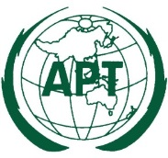 | ASIA-PACIFIC TELECOMMUNITY | Document No.:
 | The 4th Meeting of the APT Preparatory Group  for PP-22 (APT PP22-4) | APT PP22-4/INP-xx
 | 1-5 August 2022, Thailand, Bangkok | xx June 2022

Country

Title

- ABSTRACT

[Please provide a short abstract of your proposal in this section]

- INTRODUCTION

[Please provide introduction of your proposal in this section]

- PROPOSAL

[Please provide details of your proposal in this section]

