The 4th Meeting of the APT Conference Preparatory Group for WRC-23 (APG23-4)
15 - 20 August 2022
Bangkok, Thailand

INFORMATION FOR PARTICIPANTS

The 4th Meeting of the APT Conference Preparatory Group for WRC-23 (APG23-4) is scheduled to be held from 15 to 20 August 2022 in Bangkok, Thailand with physical attendance as well as virtual/online participation through Zoom meeting platform (i.e., hybrid meeting). The event will be organized by the Asia-Pacific Telecommunity (APT).

Please find the following information for the convenience of participants.

VENUE
The APG23-4 will be held at the Swissôtel Bangkok Ratchada Hotel, Bangkok, Thailand. The contact details of the hotel are as follows:

Swissôtel Bangkok Ratchada
Address: 204 Ratchadapisek Road,
Huay Kwang, Bangkok 10320,
Thailand
Tel: Tel: +66 2 694 2222
URL: https://www.swissotelbangkok.com/

PARTICIPATION

All APT Members, Associate Members, Affiliate Members and International/Regional Organizations can attend the meeting by registering online. Member Administrations and International/Regional Organizations are requested to send the official List of Delegations for the meeting and to nominate Head of Delegation (HoD) and Alternate HoD. If any APT Affiliate Member is included in the National Delegation, please clearly mention in the List of Delegation.

Participation of Non-Members: Non-Members cannot attend the meeting. Non-Member participants under National Delegation are allowed upon submission of a letter of nomination signed by the responsible officer of the APT Members.

Please indicate the mode of your participation at the online registration form. For physical attendance, the Attachment 1 provides some relevant information as of 1 July 2022. Please check the latest information with relevant authorities and organizations as the conditions may change.
Since the number of physical attendances influences some preparations for the meeting venue and other arrangements, your administration/organization is kindly requested to register delegates for physical attendance preferably by the date specified in the following section.

Virtual participation will be arranged by using Zoom meeting platform. Detail information for virtual participation will be sent to the registered delegates who wish to attend virtually.

REGISTRATION

For both physical and virtual/online attendance, registration can be done online at https://www.apt.int/content/online-registration, preferably by 15 July 2022 for physical attendance and by 1 August 2022 for virtual/online attendance, for making necessary arrangements. Only the registered participants are entitled to attend the meeting.

HOTEL ACCOMMODATION & RESERVATION

Swissôtel Bangkok Ratchada is recommended for all participants to stay during the meeting. Please make your hotel reservation in order to be eligible for the special rates given below at the earliest possible date or not later than 15 July 2022. The Swissôtel Bangkok Ratchada has created hotel reservation online for this meeting.

Please make hotel reservation online at https://bit.ly/3zbZQ0H.

Room Type | Room Rate
Swiss Premier Room (Single) | THB 2,300
Swiss Premier Room (Double/Twin) | THB 2,600
Swiss Advantage (Single) | THB 2,600
Swiss Advantage (Double/Twin) | THB 2,900
Swiss Executive (Single) | THB 3,200
Swiss Executive (Double/Twin) | THB 3,500
** Room rates are inclusive of breakfast 7.00am-10.30am., Complimentary Wi-Fi throughout the hotel area and broadband Internet in room., 10% service charge and 7% VAT

The above-mentioned types of room are available on a first come first served basis. Participants are recommended to make early reservations in order to get the rooms of their choice. The hotel cancellation policy is as follows:

- 100% of the reservation must be paid upon arrival. If the reservation is not cancelled 72 hours before arrival, the first night will be charged. If the reservation is cancelled less than 24 hours before arrival, the total amount will be charged.
- In case of No Show, the hotel will charge the full amount of your reservation to your credit card.

Check in at 14:00 hours; check out before 12:00 hours.
All bookings must be secured by a major credit card.

Due to the limited availability of rooms, APT Secretariat may not be able to guarantee hotel reservation and special rates after 15 July 2022.

CONDITIONS FOR TRAVELING TO THAILAND (From 1 July 2022)

Please refer to Attachments:
Attachment 1: Conditions for traveling to Thailand (From 1 July 2022)
Attachment 2: Vaccines Approved by Thailand and recommended timeframe for each vaccine type

MEETING WEBSITE, MEETING DOCUMENTS AND CONTRIBUTION GUIDELINES

Related information about the meeting and meeting documents will be available at the APT Website at: https://www.apt.int/2022-APG23-4.

Contributions for the meeting from APT Members, Associate Members, Affiliate Members, Regional and International Organizations are welcome. Please refer to the ‘Information for submitting Contributions to APG23-4’ for the preparation and submission of contributions. Contributions will be posted on APT website prior to the starting of the meeting. Last date of receipt of your contributions by APT Secretariat is 8 August 2022. Please submit contributions and any query on the documentation to aptapg@apt.int.

WIRELESS LAN

Internet Access over wireless network will be available during the meeting in all meeting rooms. Participants who attend physically and wish to utilize wireless LAN facility are kindly requested to bring their own laptop computers with Wi-Fi capability.

TRANSPORTATION FROM THE AIRPORT TO THE HOTEL

Physical participants are requested to use public transportation facilities of the Suvarnabhumi International Airport, Thailand. For more information, please visit website: http://www.bangkokairportonline.com/.

For your general information, the following transportations are available from Suvarnabhumi International Airport to the Hotel:

- Public Meter Taxi is located on 1st floor of the Arrival Hall, entrance 4 and 7. Fare shown on meter, plus THB 50 surcharge for boarding at the airport.

- Airport Limousine Service, the limousine service to various destinations in the city, is located at the arrival floor of the airport.

- Hotel Limousine (HOTEL/Suvarnabhumi Airport/HOTEL - One Way):

▪ Toyota Camry THB 1,700 net per car per way (max 3 persons)
▪ Benz E-Class THB 2,800 net per car per way (max 3 persons)
▪ Toyota van commuter THB 2,300 net per van per way (max 7 persons)

It takes about 50 minutes by car from Suvarnabhumi International Airport to the hotel via express way.

VISA AND IMMIGRATION INFORMATION
Thailand’s visa requirements may vary for the citizens of different countries. Please check the visa requirements with a Royal Thai Embassy or a Royal Thai Consulate-General in your respective country in advance. Kindly visit https://consular.mfa.go.th/th/page/cate-7393-general-information?menu=5d68c88d15e39c160c00827e for more details.
If you require a visa supporting letter from the APT, please contact aptadmin@apt.int.

INSURANCE

APT will not be able to bear any cost of medical or travel insurance for the participant including any measures for Covid-19 such as quarantine, PCR test, etc. APT requests Administrations/Organizations to kindly make necessary arrangements for medical, travel insurance and others covering the whole period of the event and overseas travel for the participant.

CONTACT INFORMATION

For any further information about APG23-4, please contact:

APT Secretariat
12/49, Soi 5, Chaeng Watthana Road, Lak Si, Bangkok 10210, Thailand
Phone: +66 2 573 0044
Fax: + 66 2 573 7479
Email: aptapg@apt.int

Attachment 1

Conditions for traveling to Thailand (From 1 July 2022)

Updates on Thailand Pass

• The Government of Thailand announced to discontinue/lift Thailand Pass registration for all travelers, both Thais and foreigners.

• The current USD 10,000 insurance requirements for COVID treatment for foreign travelers will no longer be mandatory but is highly recommended.

• Travelers still need to show proof of either a vaccine certificate OR COVID-Free test results. Vaccine certificate or Pro-ATK/RT-PCR results (within 72 hours) will be checked by airline staff at check-in and once again when travelers arrive in Thailand.

• This new Thailand Pass measure will be effective from 1 July onwards.

source: Center for COVID-19 Situation Administration (CCSA), Thailand

Attachment 2

Vaccines Approved by Thailand and recommended timeframe for each vaccine type

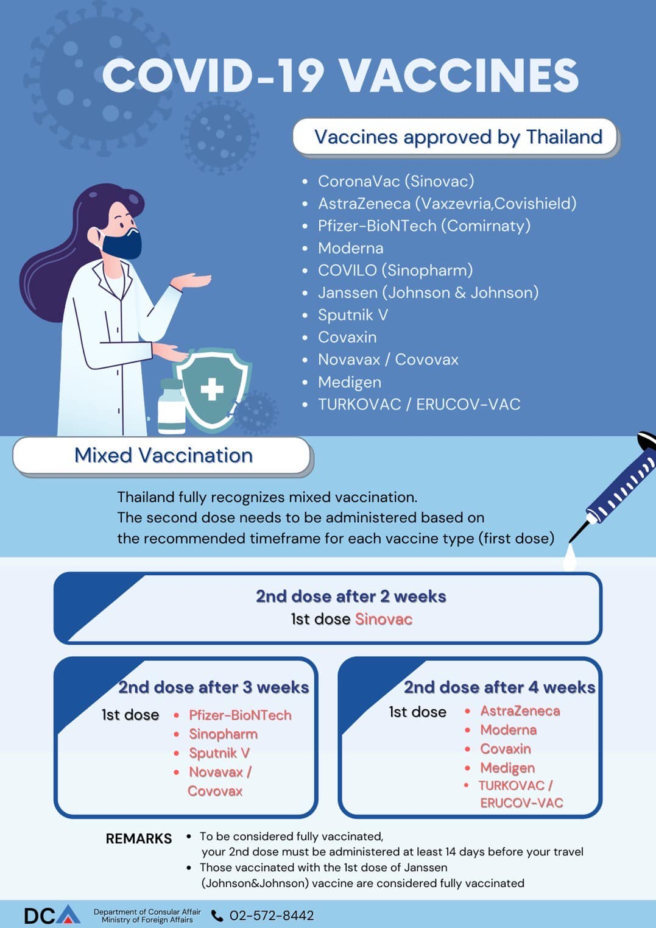
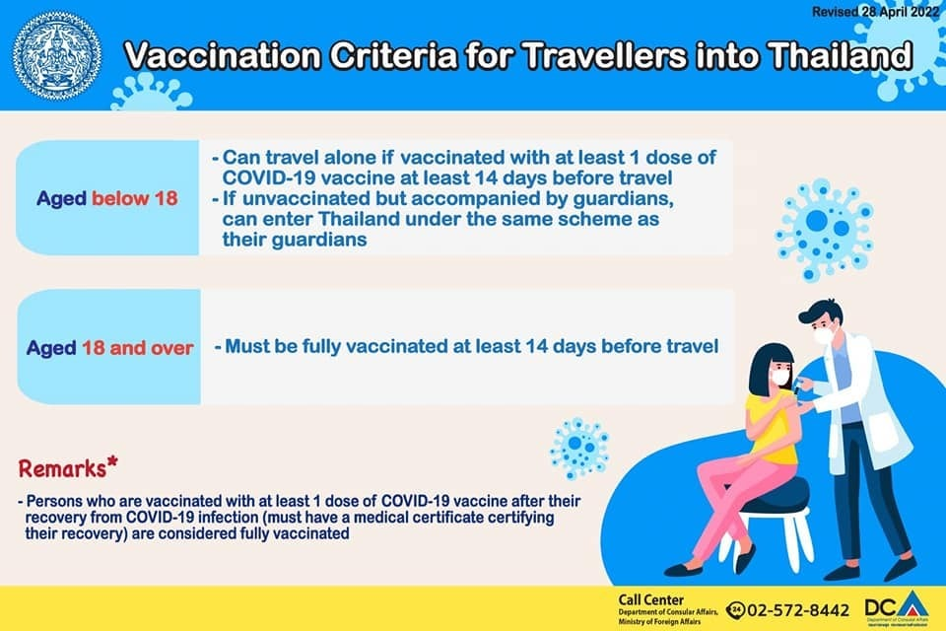

MAP OF THE HOTEL

For map of Swissôtel Bangkok Ratchada: please click see the map inside this below link:

https://www.swissotelbangkok.com/

Hotel name in Thai language to be shown to taxi driver:

“โรงแรมสวิสโฮเต็ล กรุงเทพ รัชดา”

Note: Many taxi drivers do not have a clear understanding of English. Therefore, please collect the hotel card and show to the taxi driver on your return to the hotel.

__________________

