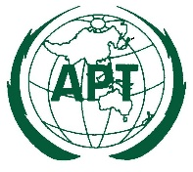 | ASIA-PACIFIC TELECOMMUNITY | Document No.:  ASTAP-33/INP-XX
The 33rd APT Standardization Program Forum
(ASTAP-33)
 | 7–15 June 2021, Virtual/Online Meeting | XX April 2021

Source

PROPOSAL Title

