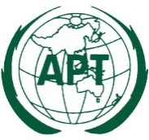 | ASIA-PACIFIC TELECOMMUNITY
 | The 1st Meeting of the APT Conference Preparatory Group for WRC-23
 | 24 – 25 September 2020, Virtual Meeting | 29 July 2020

Chairman, APT Conference Preparatory Group

Provisional Agenda

- Opening

- Adoption of agenda

- Objectives of the meeting

- Outcomes of the 43rd Session of the Management Committee of the APT

- Chairman’s report on the APG activities for RA-19 and WRC-19

- Outcomes of the RA-19, WRC-19 and CPM23-1

- Election of the Chairman for APG-23

- Election of two Vice-Chairmen for APG-23

- Discussion and adoption of structure of APG-23

- Nomination of the Chairmen for the Working Parties and Editorial Committee

- Discussion and adoption of the tentative workplan of APG-23 for the preparation of RA-23 and WRC-23

- Approval of the output documents

- Date and venue of APG23-2

- Any other matters

- Closing

