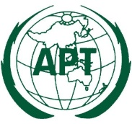 | ASIA-PACIFIC TELECOMMUNITY
 | The Meeting of the SATRC Working Group on Policy, Regulation and Services
 | 18 – 19 April 2017, Dhaka, Bangladesh

provisinal Agenda

- Opening

- Approval of agenda

- Review of outcomes of the 17th SATRC Meeting

- Review the previous activities of Working Group on Policy, Regulation and Services

- Discussion and adoption of the terms of reference for each Work Items and detail work plan:

  - Policy and regulatory aspects of infrastructure sharing
  - ICT regulatory framework for M2M communications and IoT for the SATRC countries
  - Enhanced consumer protection in digital economy (taking into account the issues of Cybersecurity, Big Data and Data sovereignty)
  - Regulatory approaches to enhance broadband experiences
  - Regulatory framework for Mobile Virtual Network Operators (MVNO)

- Related presentations by the experts

- Discussion on the draft outcomes for the Work Items

- Any other business

- Closing

____________

