 | The 5th Meeting of the APT Preparatory Group for  the ITU Plenipotentiary Conference 2026  (APT PP26-5)  24 – 28 August 2026, Brisbane, Australia | 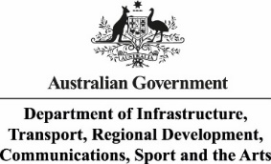

INFORMATION FOR PARTICIPANTS

The 5th Meeting of the APT Preparatory Group for the ITU Plenipotentiary Conference 2026 (APT PP26-5) is scheduled to be held from 24 to 28 August 2026 in Brisbane, Australia via physical meeting with remote participation modality. The event will be organized by the Asia-Pacific Telecommunity (APT) and co-hosted by the Australian Government Department of Infrastructure, Transport, Regional Development, Communications, Sport and the Arts.

Please find the following information for the convenience of participants.

- MEETING VENUE

The APT PP26-5 will be held at InterContinental Brisbane. The contact details of the hotel are as follows:

Address: 190 Elizabeth Street, Brisbane City, Queensland 4000, Australia
Phone: +61 (07) 3234 2000
Email: general.icb@ihg.com
URL: https://www.ihg.com/intercontinental/hotels/us/en/brisbane/bnehb/hoteldetail

- PARTICIPATION

All APT Members, Associate Members and Affiliate Members may participate in the activities of the APT-PP. Organizations which have a Memorandum of Understanding (MoU) with the APT or other relevant international or regional organizations may send representatives to attend APT-PP meetings on the same basis as they attend other APT meetings.

Non-APT members may be invited to participate in the activities of APT-PP as guests at the discretion of the Chair and the Secretary General in consultation with the relevant Member Administration, as appropriate. Other non-APT members may participate with observer status with the payment of the relevant participation fee at the discretion of the Chair and the Secretary General in consultation with the relevant Member Administration, as appropriate.

Since the number of physical attendances influences some preparations for the meeting venue and other arrangements, your administration/organization is kindly requested to register delegates for physical attendance by the date specified in the following section.

Remote participation will be arranged by using Zoom meeting platform. Detailed information for remote participation will be sent to the registered delegates who wish to attend virtually.

- REGISTRATION

For both physical and remote attendance, registration can be done online at https://apt.int//content/online-registration by 10 August 2026 for making necessary arrangements. Please indicate the mode of delegates’ participation in the online registration form. Only registered participants are entitled to attend the meeting.

- HOTEL ACCOMMODATION AND RESERVATION

The following hotels are recommended for accommodation of delegates during the meeting (please see map: APT PP26-5 recommended hotels):

InterContinental Brisbane (Recommended accommodation)

Address: 190 Elizabeth Street, Brisbane City, Queensland 4000, Australia
Front desk: +61 (07) 3234 2000
Reservations: 1 800 221 335
Email: general.icb@ihg.com
URL: https://www.ihg.com/intercontinental/hotels/us/en/brisbane/bnehb/hoteldetail
Booking link: 5th Meeting of the APT Preparatory Group

Room Type | Room Rate / Night | Deadline of Reservation
Classic Room | AUD 320 | Guests are recommended to make their reservations using the APT PP26-5 booking link as early as possible to guarantee a room.  Starting from 22 April, the hotel has the right to release some rooms to the market. On 8 August 2026, all unsold rooms will be released to the market.
Check in time: 15:00 / Check out time: 11:00

Room rates are inclusive of complimentary Wi-Fi, and include breakfast, taxes and fees.

A credit card guarantee for accommodation rooms is required. The guest who has booked the room is liable for any cancellation, no-show charge or unpaid accounts in relation to their booking.

HOTEL AMENITIES & CHARGES

CHECK-IN & CHECK-OUT | While every effort will be made to have your rooms ready as soon as possible, guaranteed check-in time is 15:00 hours. Check-out time is 11:00 hours.  Guaranteed early check-in and late check-out can be arranged on request, subject to availability and will incur an additional charge. Requests for early check-in or late check-out should be submitted to your Groups Coordinator with the delegate rooming list.
GROUP LUGGAGE | Please arrange for all delegates to clearly label their luggage by guest and group name. Please note that a charge of $15.00 per hotel room apply for delivery.
MINI BAR REMOVAL | Mini bar can be removed from $20.00 per room
CAR PARKING | Valet parking is available at a cost of $60.00 per vehicle per day, for our accommodation guests only. Valet parking is subject to availability and cannot be pre-booked.
GROUP TRANSFERS | Please advise the Hotel of all details of group transport including; name of transport company, arrival time, departure time, number of vehicles and number of delegates. Requests for coach pick up and drop off are required to be submitted to your Event coordinator 30 days prior to arrival for confirmation by the Hotel. To ensure efficient pick up and drop off, coaches are to park in the areas designated by the Hotel only.

Mercure Brisbane King George Square Hotel (Alternative Accommodation)

Mercure Brisbane
Address: Corner Ann and Roma St, Brisbane City QLD 4000
Phone: +61 7 3229 9111
Website: https://all.accor.com/hotel/8780/index.en.shtml
Email: H8784@ACCOR.COM
Booking link: https://all.accor.com/hotel/8780/index.en.shtml

How to book:
Choose your preferred hotel, Open the SPECIAL RATES drop down menu to enter the two codes:
Business Client with contract: SCP4206481
Access Code: AD289AU867
Room Type | Room Rate / Night | Deadline of Reservation
Superior Room  1 Queen bed | AUD 295*  (AUD 244 no breakfast) | Guests are recommended to book early, rates are changing daily and can increase closer to the meeting date.
Check in time: 14:00 / Check out time: 10:30
* Best rate of the day, average price for 6 nights (as at 06/05/2026), for check-in on 23 August 2026 and check-out on 29 August 2026. Breakfast, taxes and fees are included. High speed internet at additional charge.
Mercure Brisbane is located 400 m (6 min walk) from Central Station and 600 m (8 min walk) from InterContinental Brisbane.

Meriton Apartment Hotel (Alternative Accommodation)

Meriton Suites Adelaide Street
Address: 485 Adelaide St, Brisbane City QLD 4000
Phone: +61 7 3171 5100
Email: stay@meritonsuites.com.au
URL: https://www.meritonsuites.com.au/our-hotels/qld/brisbane/adelaide-street/

Room Type | Room Rate / Night | Facilities
1 Bedroom Suite | AUD 212* | King size bed, kitchen area with a full-size fridge and oven, and a coffee machine, onsite laundry, high speed internet
Check in time: 15:00 / Check out time: 10:00. Early check-in: Available upon request, but not guaranteed and subject to availability.
* Member rate, average price for 6 nights (as at 06/05/2026), for check-in on 23 August 2026 and check-out on 29 August 2026. Breakfast is not included. Taxes and fees are included. High speed internet. Flexible rate, average price for 6 nights on the date was AUD 235.

Meriton Suites at Adelaide Street is located 750 m (11 min walk) from Central Station and 1000 m (14 min walk) from InterContinental Brisbane hotel.

Meriton Suites Herschel Street
Address: 43 Herschel St, Brisbane City QLD 4000
Phone: +61 7 3999 8000
Email: stay@meritonsuites.com.au
URL: https://www.meritonsuites.com.au/our-hotels/qld/brisbane/herschel-street/

Room Type | Room Rate / Night | Facilities
1 Bedroom Suite | AUD 228* | King size bed, kitchen area with a full-size fridge and oven, and a coffee machine, onsite laundry, high speed internet
Check in time: 15:00 / Check out time: 10:00. Early check-in: Available upon request, but not guaranteed and subject to availability.
* Member rate, average price for 6 nights (as at 06/05/2026), for check-in on 23 August 2026 and check-out on 29 August 2026. Breakfast is not included. Taxes and fees are included. High speed internet. Flexible rate, average price for 6 nights on the date was AUD 248.

Meriton Suits at Herschel Street is located 850m (12 min walk) from Central Station and 1100m (16 min walk) from InterContinental Brisbane.

Guests are recommended to book early, rates are changing daily and can increase closer to the meeting date.

- VISA AND IMMIGRATION INFORMATION

Anyone who is not an Australian citizen will need a valid Australian visa to enter the country. The visa needed may depend on the country of departure. Please refer to the Australian Government Department of Home Affairs website to determine which visa is needed and apply online. Given that visa requirements can change over time, please confirm that visas are up to date prior to departure. Early submission of visa applications is recommended.

Visa application forms are available on the Department of Home Affairs’ website and applications can be lodged online. Details about how to apply are included in the information about the particular visa you wish to apply for. A list of visas is available on the website. You may be required to provide business visitor documents to support your application. In case of any questions on visas, please contact host secretariat (email: ITU@communications.gov.au).

If you require a confirmation that you have registered to participate in APT PP26-5 to facilitate your application for a visa, please contact at ITU@communications.gov.au and provide a scanned copy of your passport to facilitate the preparation of the confirmation letter.

- HOSTING OF RECEPTION

APT Members interested in hosting a reception during APT PP26-5 are kindly requested to register their interest by contacting APT Secretariat at aptpp@apt.int.

- MEETING WEBSITE, DOCUMENTS AND CONTRIBUTION GUIDELINES

Related information about the meetings and provisional meeting documents will be available at the APT Website: https://apt.int/Meeting/2026-PP26-5

APT Members who wish to submit contribution(s) on the agenda items should prepare their contribution(s) in Microsoft Word and/or PowerPoint, English version and in a proper template provided by the APT Secretariat and send it to aptpp@apt.int. APT Associate Members and Affiliate Members, based on the agreement with the corresponding APT Members, can submit Input contribution to the meeting, otherwise it will be treated as Information document. International/Regional organizations, having interests in APT PP-26, are welcome to submit Information document to the meeting.

The firm deadline for the submission of contribution(s) is 14 August 2026. However, it is encouraged to submit the contributions, preferably at least two weeks before the meeting, by 10 August 2026, to facilitate effective preparation. The template for submission of contribution is available on the APT website.

- WIRELESS INTERNET

Internet Access over wireless networks will be available during the meeting. Participants who attend physically and wish to utilize the wireless LAN facility are kindly requested to bring their own laptop computers/devices with Wi-Fi capability.

- TRANSPORTATION FROM THE AIRPORT TO THE HOTEL

Physical participants are encouraged to make their own transport arrangements to and from Brisbane Airport. The distance from the airport to InterContinental Brisbane is 14.4 kilometers, which takes about 20 to 30 minutes by car/taxi, or from 30 to 45 minutes by public transport. Outside of peak periods, it is approximately a 20 minute drive from the airport to the city. You can expect to pay $67 to $82 for the one-way trip (1 to 4 passengers). Please note there is a fee of $4.86 added to any fares collected from the airport. Remember that toll road fees are in addition to any cab fare and are the responsibility of the passenger.

Taxi
Brisbane and its suburban areas are serviced by two taxi companies:
- 13cabs: 13 22 27
- Black & White Cabs: 133 222

Rideshare and Uber
Booking a rideshare service is easy. Brisbane Airport enables rideshare pick up services, including Uber, Didi, Ola and Sheba. Simply order your rideshare using your preferred app and follow the signs to the designated Rideshare Booking areas to meet with your driver.

At International Terminal
From Level 2, take the lift or escalator down to Level 1, follow the Rideshare Booking signs towards the open air car park on the left as you exit the Terminal building (towards the city). You can also follow the map in your rideshare app to the pick up location.

What does it cost?
You can use Uber’s fare estimator or your rideshare app to work out the cost of your trip. Please note that a fee of $4.86 is added to your fare if you’re using a Rideshare service from the airport.

Shuttle Bus
If you’re looking for a door-to-door transfer to and from Brisbane Airport, consider using the Con-x-ion shuttle bus transfer service.

Con-x-ion operates from both Terminals with a pick up and drop off service that goes door-to-door to dozens of locations around Brisbane. Tickets can be purchased online or at the sales kiosk at each Terminal. To book visit the Con-X-ion website. Meet your transfer at the Visitor Information desk in the International Terminal.

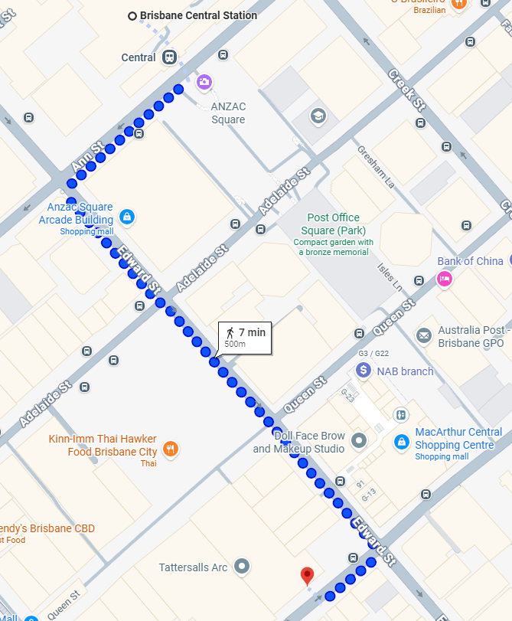
Public transport
The Brisbane Airtrain is a quick and easy option for travelling between Brisbane Airport and Brisbane City in just 20 minutes, but riders will need to walk about 500m (7 minutes) from Brisbane Central Station to InterContinental (see image).

Finding the Airtrain Station
At the International Terminal: take the travelator or lift to Level 3 of the Terminal building and follow the signs to the station.

Train services run every 15 minutes during peak times and every 30 minutes off-peak periods. To use this service, book your ticket on the Airtrain website. Purchase tickets on arrival at the Airtrain Station, travel using go card or contactless debit or credit card.

For more information including ticket pricing and travel planners, visit the Airtrain website.

Delegates can enjoy a discounted Airtrain return fare between 14 and 31 August 2026, with an online promo code from the Business Economic Development Agency team. Please complete the registration form, and they will be in touch with all the details. For ‘Specific acronym for your event promocode’ field, please use ‘APT PP26-5’. The code is valid until 29 August 2026.

Delegates will get discounted travel fare: $16 one way / $32 return per person (full-price tickets between Brisbane Airport and Brisbane City stations are $22.30).

Hours of operation: Weekdays: 5:04am - 10:04pm / Weekends: 6:04am –
10:04pm

City Council Bus Service
Brisbane City Council operates a bus service within the airport precinct. Bus route 590 runs seven days a week. However, travel by bus is not recommended as you would need to catch the bus to the rail network at the Toombul Interchange for a range of public transport options to the city. You may wish to choose this option if you have little baggage, prepared to walk and familiarize yourself with your route in advance. If that is what you are ready to do, visit the Translink website for more information, maps and timetables.

- CODE OF CONDUCT

The Code of Conduct requires that all participants in connection with APT meetings or events, whether virtual, hybrid or physical, must observe professional, respectful and responsible conduct at all times, bearing in mind zero tolerance on discrimination or intimidation against cultural, ethnic, religious and gender differences to facilitate a safe and inclusive environment.

- INSURANCE AND MEDICAL EMERGENCIES

Due to the procedural difficulties and budgetary constraints, the APT and the host will not be able to bear the cost of insurance for the participants, any medical expenses or any other expenses. The APT Secretariat, therefore, request your administrations/organizations to kindly make necessary arrangements for insurance and medical coverage of your participants before traveling to Australia.

- PRACTICAL INFORMATION

About Australia
Official Name: Australia
Population: 25.69 million (2021)
Capital City: Canberra
Area: 7.682 million km²
Religion: Christianity (43.9%), No religion (38.9%), Islam (3.2%),
Hinduism (2.7%), Buddhism (2.4%), Other (1.7%)
Language: English
International dialing code: +61

Weather
August is a winter month in Australia. In August, the mean daily maximum temperature for Brisbane is 22.1°C and the mean daily minimum is 10.0°C, with 3.7 rainy days on average (>1mm) (for Brisbane Airport area).

Time Zone:

GMT +10:00

Banks & Currency
All major credit cards are accepted in Adelaide. Australian dollars are the local currency Exchange Rates | RBA.

Electricity:

220-240V, 50 Hz.

A standard Outlet:
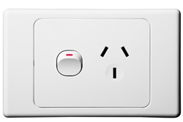

- CONTACT INFORMATION

APT Secretariat  Asia-Pacific Telecommunity (APT)  12/49 Soi 5 Chaeng Watthana Road  Bangkok 10210, Thailand  Phone: +66 2 573 0044  Fax: +66 2 573 7479  Email: aptpp@apt.int | Local Secretariat  Department of Infrastructure, Transport, Regional Development, Communications, Sports and the Arts  Address: Level 5 Nishi Building, 2 Phillip Law Street, Canberra ACT 2601, Australia  Email: ITU@communications.gov.au

