 | The 3rd Meeting of the APT Conference Preparatory Group for WRC-27  (APG27-3)  27 – 31 July 2026, Sapporo, Japan | 

INFORMATION FOR PARTICIPANTS

The 3rd Meeting of the APT Conference Preparatory Group for WRC-27 (APG27-3) will be held from 27 to 31 July 2026 in Sapporo, Japan. The meeting will be organized by the Asia-Pacific Telecommunity (APT) and hosted by the Ministry of Internal Affairs and Communications of Japan as a physical meeting with remote participation modality. Remote participation will be arranged through Zoom meeting platform.

APG27-3 will be preceded by the ‘Training Course on Preparing for International Conferences: APG/WRC’ which will be held physically from 22 to 24 July 2026 at the same venue. The training course aims to provide an opportunity for the young generation who are new to international conferences to understand the international decision-making process including how to make presentations and coordination. This year, the event will focus on understanding of the structure and the decision-making process of APG and WRC. For details information on the Training Course please visit APT website at https://apt.int/apt/2026-TCPIC-APG. The Training Course will be funded through the extra budgetary contributions by the Ministry of Internal Affairs and Communications (MIC), Japan.

The detailed arrangements are as follows:

- VENUE

International Convention Center Pamir, Sapporo Prince Hotel
Address: Nishi 11-chome, Minami 2-jo, Chuo-ku Sapporo, 060-8615 Japan
Tel: +81-(0)11-241-1111
URL: https://www.princehotels.com/sapporo/

- PARTICIPATION

All APT Members, Associate Members, Affiliate Members, International/Regional Organizations, and Eligible Non-Members can participate in the meeting by registering online through the APT Website.

Administrations of Members and Associate Members and International/Regional Organizations are kindly requested to send the official list of delegations for the meeting and to nominate Head of Delegation (HoD) and Alternate HoD. If any APT Affiliate Member is included in the National Delegation, please clearly mention it in the List of Delegation.

Participation of Non-Members: Non-Members cannot attend the meeting. Non-Member participants under national delegation are allowed once their names are included in the official list of delegation. Please indicate the mode of your participation at the online registration form. Since the number of physical attendances influences some preparations for the meeting venue and other arrangements, your administration/organization is kindly requested to register delegates for physical attendance preferably by the date specified in the following section. Non-member participation from the host country, Japan, are allowed as ‘Observers’ if they are approved by the Ministry of Internal Affairs and Communications, Japan.

Remote participation will be arranged for all sessions including all WP and DG meetings of APG27-3 with the following notes in order to facilitate the effectiveness of the meetings:
- All Office Bearers and DG Chairs must attend the meeting in person to conduct the meetings
- All contributors who submit contribution(s) to APG27-3 are strongly expected to attend the meeting in person
- Other participants are highly encouraged to attend the meeting in person
- In case offline consultation is required during the meeting, the offline consultation will be conducted only among in-person participants, and remote participants shall respect the outcomes of the offline consultation
- All participants of APG27-3 are invited to bring their own ear sets.

- REGISTRATION

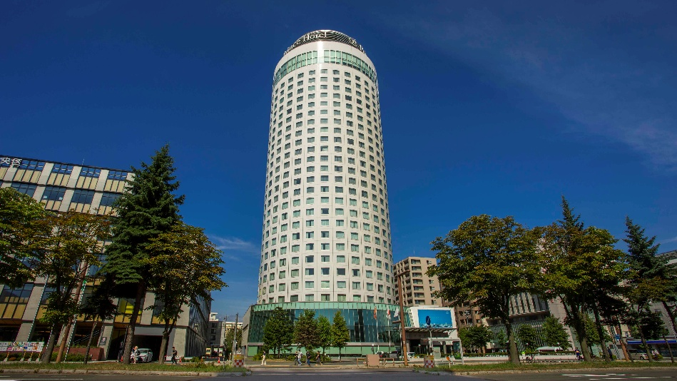
Registration of delegates can be done online at https://www.apt.int/content/online-registration. For planning and logistical arrangements for physical participation, it is suggested to register on or before 5 July 2026. Please note that physical participation will not be guaranteed after this closing date.

- HOTELS FOR ACCOMODATION

Sapporo Prince Hotel is recommended for the accommodation of the delegates during the meeting:

Venue Hotel: Sapporo Prince Hotel

Sapporo Prince Hotel is recommended for all participants to stay during the meeting. Please make your hotel booking in order to be eligible for the special rates given below at the earliest possible date and no later than 15 June 2026 due to the peak season and long holiday during the meeting period.

Room Type | Rates per room/per night/ breakfast included
Room Type | Sunday to Thursday | Friday to Saturday
Club King Room  or Club Twin Room  SINGLE occupancy | JPY 56,000 | JPY 78,000
Room Type | Rates per room/per night/ breakfast included
Room Type | Sunday to Thursday | Friday to Saturday
Club King Room  or Club Twin Room  DOUBLE occupancy | JPY 58,000 | JPY 82,200
Standard Twin Room  SINGLE occupancy | JPY 24,300 | JPY 37,400
Standard Twin Room  DOUBLE occupancy | JPY 25,600 | JPY 39,600

Please click on the link below to make a hotel reservation at Sapporo Prince Hotel.
URL: https://www.seibumice.com/mice/contents/APG27No3/

The room rates quoted above are in JPY and include buffet breakfast. The above rates are inclusive of Consumption tax, 13% Service charge and Accommodation tax. Participants are recommended to make early reservations in order to secure accommodation due to peak season.

Cancellation Policy:
- The day before check in: 20% of the room charge
- The day of check in: 100% of the room charge
- No show: 100% of the room charge
Hotel check-in time is 15:00 hours. Hotel check-out time is 11:00 hours.

All bookings must be secured with a major credit card. Please note that the deadline to avail of the special rates is 15 June 2026; after this date, the hotel will not be able to guarantee the discounted rates.

- TRANSPORTATION FROM THE AIRPORT TO THE VENUE
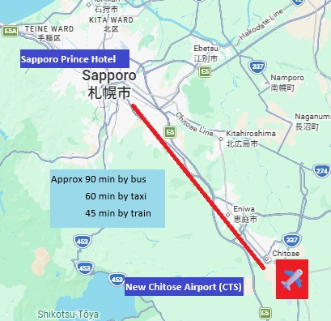

The Hotel is approximately 55 km from New Chitose Airport, and it takes about 1 hour by car.

All participants are encouraged to make their own transport arrangements from the airport to their hotels and on their return to the airport. Major modes of transport are as follows: Airport Liner bus (takes approximately 80-90 minutes), taxi (approx. 60 minutes), or JR Rapid Airport train to Sapporo Station (approx. 40 minutes) followed by a 10-minute taxi ride to the hotel.

- From New Chitose Airport to Sapporo Prince Hotel

Detailed information on how to access the hotel can be found here:
https://www.princehotels.com/sapporo/map-direction/

Airport website also has detailed information on how to reach the Sapporo city center:
https://www.hokkaido-airports.com/en/new-chitose/access/

Airport Liner bus
Fare: JPY 1,500/person (as of 1 April, 2026)
https://www.hokkaido-airports.com/en/new-chitose/access/bus/
https://www.hokto.co.jp/en/sapporo-chitose/

- Bus tickets can be purchased at the Transport Information Counter on the 1st floor lobby at the International Terminal Building (cash/ credit card). There’s also a ticket vending machine near the counter. Without prior purchase of tickets, Japanese transportation IC Card such as Suica/PASMO/Kitaca/ICOCA can be used to pay for the fare as you board the bus.
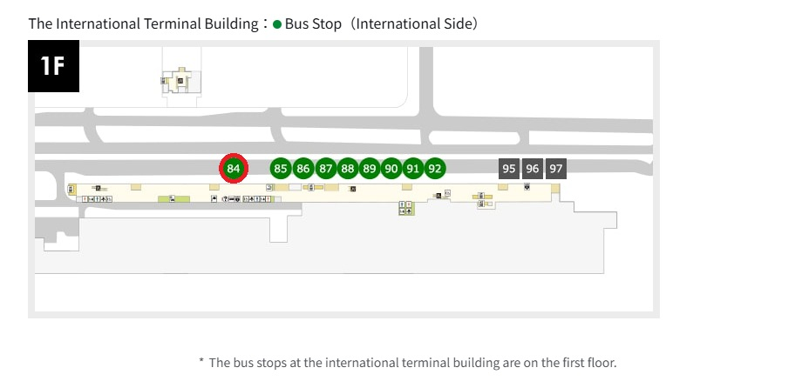
- The Airport Liner bus leaves from bus stand #84 on the 1st floor at the international terminal building.
- Bus time table can be found on the information board at the airport as well as here
https://www.hokto.co.jp/en/sapporo-chitose/ (tab “To Sapporo City Center”)
For example, the first bus leaves the international terminal at 8:46 and is scheduled to arrive at Sapporo Prince Hotel (stop #S29) at 10:05.

Taxi
Fare: approx. JPY 13,000~16,000/one way
https://www.hokkaido-airports.com/en/new-chitose/access/taxi/

- Taxi stand is found on the 1st floor of the international terminal (curbside stand #80)

JR Rapid Airport train + Taxi
Fare: JR: JPY 1,230/person (as of 1 April 2026) to Sapporo Station
Taxi: JPY 1,300~1,700/one way (may be higher during after-hours)
https://www.jrhokkaido.co.jp/global/english/travel/airport.html

- Train leaves from the underground floor of the Domestic Terminal of New Chitose Airport. Tickets can be purchased on ticket vending machines at the entrance to the train station on the B1 (underground floor 1) of the Domestic Terminal building (cash/ credit card). Select “Sapporo” as your destination. Face to face ticket counter is also available during business hours. Without prior purchase of tickets, Japanese transportation IC Card such as Suica/PASMO/Kitaca/ICOCA can be used to pay for the fare as you go through the ticket gate.
- Special Rapid train (takes 36 minutes), Rapid Train (37 min), Semi-Rapid train (43 min) as well as Local Train all stop at Sapporo Station.
- After alighting at Sapporo Station, proceed to South or North exit to find a Taxi stand.
- Taxi passenger door opens and closes semi-automatically. Please step back and wait for the driver to operate the door. The fare is paid at the end of your journey either in JPY cash or credit card.

* There is also a free shuttle bus service provided by Sapporo Prince Hotel with limited number of seats on a first-come, first-served basis. For details, please visit
https://www.princehotels.com/sapporo/map-direction/

- From Sapporo Prince Hotel to New Chitose Airport

Free shuttle bus to Sapporo Station:
07:30, 08:30, 09:30, 10:30, 11:30, 13:30, 14:30, 15:30 and 16:30

For services between 7:30 and 11:30, numbered tickets are issued at the front desk from 1 hour before the departure time.

- VISA AND IMMIGRATION INFORMATION

All foreign visitors entering Japan must have a valid passport. Visitors from countries whose citizens are required to obtain a visa should, as soon as possible and at least one month before the start date of the meeting, apply for a visa from the office (embassy or consulate) representing Japan in your country or, if there is no such office in your country, from the one that is closest to the country of departure.

You may need a letter of invitation from the Japanese host, which you will need to present to the Japanese embassy/consulate in your area in order to obtain your visa. To obtain an invitation letter, please complete the form at the following URL: https://ituaj.jp/?p=42872.

This visa support website will be available from 1 April 2026. After 1 April, please complete the form at the above URL as early as possible. In order to receive an invitation letter, your information should be provided to the host before 7 July 2026.

NOTE 1: A proof of registration to the 3rd Meeting of the APT Conference Preparatory Group for WRC-27 (APG27-3) will be requested by the host, so make sure you have registered for the APG27-3 and your focal point has approved your registration before requesting the visa invitation letter.

NOTE 2: The host will do the utmost to provide invitation letters that are requested late; however, it cannot guarantee that a visa will be received in time for the APG27-3 meeting.

The contact address for visa support in Japan is:
The ITU Association of Japan
E-mail: apg27-3-visa@ituaj.jp

For more information, please visit the website of the Ministry of Foreign Affairs of Japan at:
http://www.mofa.go.jp/j_info/visit/visa/.

- MEETING WEBSITE, MEETING DOCUMENTS AND CONTRIBUTION GUIDELINE

Related information about the meeting and provisional meeting documents will be available at the APT Website at: https://www.apt.int/2026-APG27-3.

Contributions for the meeting from APT Members, Associate Members, Affiliate Members, regional and International Organizations are welcome. You are requested to use the proper document template for your contribution. Please refer to the ‘Information for submitting contributions to APG27-3’ for detail process of submitting the contribution. The ‘Information for submitting contributions to APG27-3’ is available at the website mentioned above and embedded here as well. Contributions will be posted on APT Website prior to the starting of the meeting.

Last date of receipt of your contributions by the APT Secretariat is 17 July 2026. To submit contributions and any information on the documentation, please contact us at aptapg@apt.int.

In order to facilitate efficient meeting management and document handling process, the APT encourages the use of electronic documents during the meeting. Electronic copies of the meeting documents will be available online.

- WIRELESS LAN:

Internet Access over wireless networks will be available during the meeting. Participants who wish to utilize the wireless facility are kindly requested to bring their own laptop computers.

- INSURANCE AND MEDICAL EMERGENCIES:

Due to the procedural difficulties and budgetary constraints, the APT Secretariat will not able to bear the cost of insurance for the participants, any medical expenses or any other expenses. The APT Secretariat, therefore, request your administrations/organizations to kindly make necessary arrangements for insurance and medical coverage of your participants before traveling to Japan.

- CODE OF CONDUCT

The Code of Conduct requires that all participants in connection with APT meetings or events, whether virtual, hybrid or physical, must observe professional, respectful and responsible conduct at all times, bearing in mind zero tolerance on discrimination or intimidation against cultural, ethnic, religious and gender differences to facilitate a safe and inclusive environment.

- PRACTICAL INFORMATION

Sapporo is the capital of Hokkaido and Japan’s 5th largest city with a population of 2 million and an area of 1,121 square kilometers. Sapporo is also one of the nation’s youngest major cities.
https://www.japan.travel/en/destinations/hokkaido/hokkaido/
https://www.japan-guide.com/e/e2163.html
https://visit.sapporo.travel/

Tips for walking around town: Streets of Sapporo are numbered 1,2,3…, East-west (approx.) street numbering starts from Odori boulevard, 1st street on the South of Odori being Minami (south) 1-Jo, 2-Jo…etc., and on the North being Kita (north) 1-Jo, 2- Jo…etc. North-south street numbering starts from Sosei river, with 1st street on the East of the river being Higashi (east) 1-Chome, then 2-Chome...etc., and on the West being Nishi (west) 1-Chome, 2- Chome…etc.

Weather: Late July in Sapporo falls in the middle of summer. The daily low is about 18 degrees Celsius and the daily high is about 26 degrees Celsius, with monthly rainfall about 90 mm (data from the Japan Meteorological Agency). A folding umbrella may be convenient in case of rain.

Time Zone: UTC+9. (Japan does not observe daylight-saving time.)

Banks & Currency: The currency used in Japan is the Japanese yen (JPY). There are four kinds of bills (10,000-yen, 5,000-yen, 2,000 yen and 1,000-yen) and six kinds of coins (500-yen, 100-yen, 50-yen, 10-yen, 5 yen and 1 yen) used. Major foreign currencies may be exchanged into JPY at foreign exchange services at New Chitose Airport. Sapporo Prince Hotel also has an exchange machine for major foreign currencies (into JPY only) available 24 hours a day.
Major credit cards are widely accepted in Japan. However, cash may still be required at local small shops. Visa, MasterCard, JCB and American Express are commonly used. The exchange rate (TTB) as of 23 March 2026 is JPY 159.06to USD 1.
Tipping is not customary in Japan.

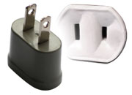
Electricity: The standard power supply in Japan is 100 volts. The frequency is 50 Hz in eastern Japan including Sapporo. The type of power outlet/connector used in Japan is “Type A” which has a two-parallel-pronged plug. For your convenience, please bring a multi-voltage travel adapter.
Type A plug

Emergency phone: Emergency call for Police: 110
Emergency call for Fire Department and Ambulance: 119

- CONTACT INFORMATION

APT Secretariat  Asia-Pacific Telecommunity (APT)  12/49 Soi: 5 Chaeng Watthana Road  Bangkok 10210, Thailand  Phone: + 66 2 573 0044  Fax: +66 2 573 7479  E-mail: aptapg@apt.int | Local Secretariat  c/o ITU Association of Japan  1-17-11 Shinjuku, Shinjuku-ku,  Tokyo 160-0022, Japan  E-mail: apg27-3-local@ituaj.jp  Phone: +81 3-5357-7614 (Ms. Mariko Shimizu)  (The number is for emergency only. Due to time difference, please use Email for regular correspondences.)  Fax: +81-3-5356-8170

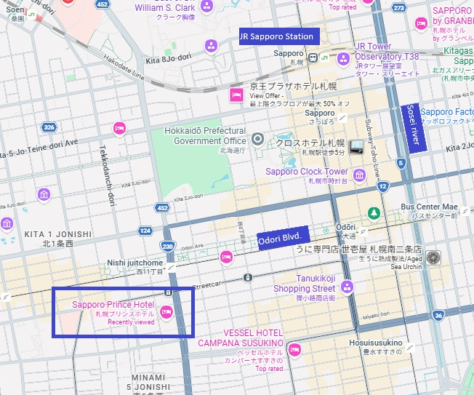
- HOTEL MAP

Hotel name in Japanese language:
札幌プリンスホテル
______________

