

The 2nd Meeting of the APT Conference Preparatory Group for WRC-27 (APG27-2)
28 July – 1 August 2025, Pattaya, Thailand

INFORMATION FOR PARTICIPANTS

The 2nd Meeting of the APT Conference Preparatory Group for WRC-27 (APG27-2) will be held from 28 July to 1 August 2025 in Pattaya, Thailand. The meeting will be organized by the Asia-Pacific Telecommunity (APT) as a physical meeting with remote participation. Remote participation will be through Zoom meeting platform.

The detailed arrangements are as follows:

- VENUE

Centara Grand Mirage Beach Resort Pattaya

Address: 277 Moo 5, Naklua, Banglamung, Pattaya 20150, Thailand
Tel: +66 (0) 3830 1234
Fax: +66 (0) 3871 4999
URL: https://www.centarahotelsresorts.com/centaragrand/cmbr

- PARTICIPATION

All APT Members, Associate Members, Affiliate Members, International/Regional Organizations, and Eligible Non-Members can participate in the meeting by registering online through the APT Website.

Administrations of Members and Associate Members and International/Regional Organizations are kindly requested to send the official list of delegations for the meeting and to nominate Head of Delegation (HoD) and Alternate HoD. If any APT Affiliate Member is included in the National Delegation, please clearly mention it in the List of Delegation.

Participation of Non-Members: Non-Members cannot attend the meeting. Non-Member participants under national delegation are allowed once their names are included in the official list of delegation. Please indicate the mode of your participation at the online registration form. Since the number of physical attendances influences some preparations for the meeting venue and other arrangements, your administration/organization is kindly requested to register delegates for physical attendance preferably by the date specified in the following section.

Remote participation will be arranged for all sessions including all WP and DG meetings of APG27-2 with the following notes in order to facilitate the effectiveness of the meetings:
- All Office Bearers and DG Chairs must attend the meeting in person
- All contributors who submit contribution(s) to APG27-2 are strongly expected to attend the meeting in person
- Other participants are highly encouraged to attend the meeting in person
- In case offline consultation is required during the meeting, the offline consultation will be conducted only among in-person participants, and remote participants shall respect the outcomes of the offline consultation
- All participants of APG27-2 are invited to bring their own ear sets.

- REGISTRATION

Registration of delegates can be done online at https://www.apt.int/content/online-registration.
For planning and logistical arrangements for physical participation, it is suggested to register on or before 11 July 2025. Please note that physical participation will not be guaranteed after this closing date.

- HOTELS FOR ACCOMODATION

Following hotels are recommended for the accommodation of the delegates during the meeting:

- Venue Hotel: Centara Grand Mirage Beach Resort Pattaya
Centara Grand Mirage Beach Resort Pattaya is recommended for all participants to stay during the meeting. Please make your hotel booking in order to be eligible for the special rates given below at the earliest possible date and not later than 30 May 2025 due to the peak season and long holiday during the meeting period.
Room Type | Room Rate per night
Deluxe Explorer King (Single) | THB 5,000.- net/room
Deluxe Explorer Twin | THB 5,000.- net/room

Please click on the link below to make a hotel reservation at Centara Grand Mirage Beach Resort Pattaya. You can fill out the reservation form below and send the form to e-mail address: TechineeLo@chr.co.th and Saranvichde@chr.co.th.

The room rates quoted above are in Thai Baht and includes broadband internet access and buffet breakfast. The above rates are inclusive of 10% service charge and VAT. Participants are recommended to make early reservations in order to secure accommodation due to peak season.

Cancellation Policy:
- In the event of cancellations 10 days or less prior to arrival – Cancellation fee will be charged 100% of period stay.
- Non arrival or no show - cancellation fee will be charged at 100% of period stay.
Hotel check-in time is 15:00 hours. Hotel check-out time is 12:00 hours.
All bookings must be secured by a major credit card.
As deadline for booking at special rates is 30 May 2025, the hotel will not be able to guarantee special rates after 30 May 2025.
- Alternate Hotel: Pullman Pattaya Hotel G
Participants are kindly requested to make their reservations directly through the hotel's website at this link Asia-Pacific Telecommunity Meeting from 27 July - 2 August,2025 (check-in/out dates). The rates will be in accordance with the rates on the hotel's website.
Should participants have any further questions regarding the reservation process of this hotel, please contact the hotel directly at phatcharaporn@pullmanpattayahotelg.com. Kindly copy the following team members of this hotel as well: sales-co@pullmanpattayahotelg.com; sales-co1@pullmanpattayahotelg.com; pimlada@pullmanpattayahotelg.com; patcharee@pullmanpattayahotelg.com; nattakarn@pullmanpattayahotelg.com

Cancellation and Penalty Policy:
The cancellation and penalty policy will be displayed when making the hotel reservation. Please read carefully and follow their instructions.

All bookings must be secured by a major credit card.

- TRANSPORTATION FROM THE AIRPORT TO THE VENUE

For the information of the physical participants, the following transportations are available from Suvarnabhumi International Airport to the Hotel and vice versa. The Hotel is approximately 120 km. from Suvarnabhumi International Airport, and it takes about 2 hours by car from Suvarnabhumi International Airport to the hotel.

  - Shuttle Coach Services

All participants are encouraged to make their own transport arrangements from the airport to the hotels and on their return to the airport. Shared transfer by Bell Travel Service is recommended for all the participants. There are two channels to purchase tickets:

- Online purchases via website as shown below: http://www.belltravelservice.com
Reservations can be made from one month before travel.

Please read the Remarks, Cancellation Policy and Terms and Conditions carefully when making an online purchase.

- Purchase at ticket counter at Suvarnabhumi Airport located at Level 1 near Gate Number 8, Counter for “PATTAYA-HUA HIN” (counter’s name). Please inform the staff at the counter that your destination is Centara Grand Mirage Beach Resort Pattaya or Pullman Pattaya Hotel G. The return ticket can also be bought from this counter.

- From Suvarnabhumi International Airport to Pattaya
The schedules of the Coach: 08:30, 10:30, 12:30, 14:30, 16:30 and 18:00 hrs.
Approx. THB 300/person (exclude service charge)

- Please be advised that participants, travelling to Pattaya by coach need to transfer to a van at bus terminal on arrival in Pattaya to be taken to Centara Grand Mirage Beach Resort Pattaya or Pullman Pattaya Hotel G. The same applies for the return journey from the hotels.

- For online purchases, please be sure to book coach departure time at least 2 hours after your estimate time of arrival.

- The participants who arrive later than the schedule of 18:00 hrs. are recommended to use Hotel limousine. Please contact the hotel directly.

- From Pattaya to Suvarnabhumi International Airport

The schedules of the Coach: 06:00, 09:00, 11:00, 13:00, 15:00, 17:00 and 19:00 hrs.
Approx. THB 300/person (exclude service charge)

- Passengers are requested to wait at the hotel lobby 30 minutes before the departure time indicated in the above schedules.

The details of shared transfer by Bell Travel Service can be found at http://www.belltravelservice.com. Contact numbers: Bangkok Office: +66 66 114 3291; SVB Airport: +66 66 114 3293; Pattaya Office: +66 66 114 3294.

  - Centara Grand Mirage Beach Resort Pattaya – Hotel Limousine

The Hotel is approximately 120km from Suvarnabhumi International Airport and provides Limousine service from the airport to the hotel at the following rates. Please contact hotel directly through e-mail address: TechineeLo@chr.co.th.

VEHICLE MODEL | PRICE PER UNIT | MAXIMUM CAPACITY
Toyota Camry | THB 2,800 / Car/ Way | 2 passengers
Mercedes Benz E-Class | THB 8,000/ Car/ Way | 2 passengers
Toyota Commuter (Van) | THB 3,500 / Car/ Way | 6 passengers

  - Airport Limousine Service

Airport Limousine Service, the limousine service to various destinations in the city, is located at the arrival floor of the airport. If participants would like to use the service of airport limousine, please visit https://suvarnabhumi.airportthai.co.th/service/transportation/detail/253 for details and making reservation.

- VISA AND IMMIGRATION INFORMATION
Thailand’s visa requirements may vary for the citizens of different countries. Please check the visa requirements with a Royal Thai Embassy or a Royal Thai Consulate-General in your respective country in advance. Kindly visit https://consular.mfa.go.th/th/page/cate-7393-general-information?menu=5d68c88d15e39c160c00827e for more details.
If you require a visa supporting letter from the APT, please contact aptadmin@apt.int.

- MEETING WEBSITE, MEETING DOCUMENTS AND CONTRIBUTION GUIDELINE

Related information about the meeting and provisional meeting documents will be available at the APT Website at: https://www.apt.int/2025-APG27-2.

Contributions for the meeting from APT Members, Associate Members, Affiliate Members, regional and International Organizations are welcome. You are requested to use the proper document template for your contribution. Please refer to the ‘Information for submitting contributions to APG27-2’ for detail process of submitting the contribution. The ‘Information for submitting contributions to APG27-2’ is available at the website mentioned above and embedded here as well. Contributions will be posted on APT Website prior to the starting of the meeting.

Last date of receipt of your contributions by the APT Secretariat is 18 July 2025. To submit contributions and any information on the documentation, please contact us as aptapg@apt.int.

In order to facilitate efficient meeting management and document handling process, the APT encourages the use of electronic documents during the meeting. Electronic copies of the meeting documents will be available online.

- WIRELESS LAN:

Internet Access over wireless network will be available during the meeting. Participants who wish to utilize the wireless facility are kindly requested to bring their own laptop computers.

- INSURANCE AND MEDICAL EMERGENCIES:

Due to the procedural difficulties and budgetary constraints, the APT Secretariat will not able to bear the cost of insurance for the participants, any medical expenses or any other expenses. The APT Secretariat, therefore, request your administrations/organizations to kindly make necessary arrangements for insurance and medical coverage of your participants before traveling to Thailand.

10. CODE OF CONDUCT
The Code of Conduct requires that all participants in connection with APT meetings or events, whether virtual, hybrid or physical, must observe professional, respectful and responsible conduct at all times, bearing in mind zero tolerance on discrimination or intimidation against cultural, ethnic, religious and gender differences to facilitate a safe and inclusive environment.

- PRACTICAL INFORMATION

Pattaya is about 147 km South-East of Bangkok, and faces the Gulf of Siam. It is located within easy access of the Bangkok Airport and has excellent accommodation and restaurants and entertainment for all tastes. Because of its easy accessibility from Bangkok, Pattaya remains one of Thailand’s most popular weekend getaways for Bangkok’s city-dwellers

Pattaya is popular not only as a beach resort and for its entertainment, nightlife and shopping, but also for the broad selection of pastimes it caters for, from golf and horseback riding to bungee jumping, karting and shooting - not to mention a wide variety of watersports such as scuba diving, jet-skiing, sailing, water skiing, windsurfing and kitesurfing, and a whole lot more. Pattaya is also very popular as a conference, convention and seminar venue.

Weather: Average temperature in July is between 30 and 35 degree Celsius.

Time Zone: GMT + 7 hours.

Banks & Currency: The unit of Thai currency is Thai Baht (THB). The exchange rate as of April 2025, is THB 33.92 to USD 1.

Electricity: Supply voltage is 220V, 50Hz. A standard grounded Thai outlet supports European 2-pin plugs and earthed and unearthed American plugs (see picture). Please bring the right adapter for your equipment.

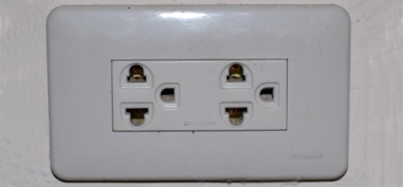

- CONTACT INFORMATION

APT Secretariat
Asia-Pacific Telecommunity (APT)
12/49 Soi: 5 Chaeng Watthana Road
Bangkok 10210, Thailand
Phone: + 66 2 573 0044
Fax: +66 2 573 7479
E-mail: aptapg@apt.int

- HOTEL MAP
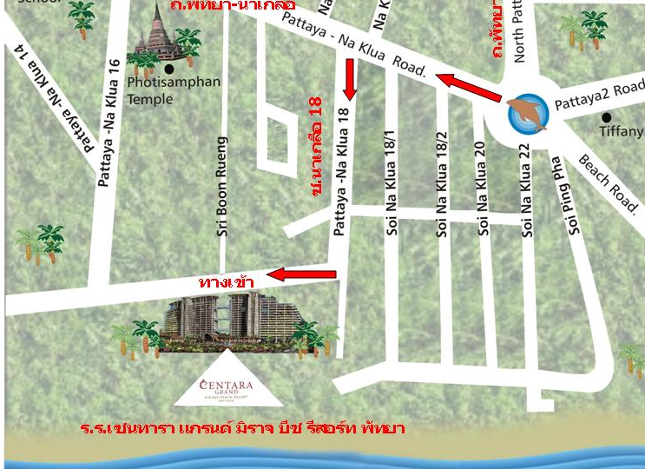
Hotel name in Thai language:
“โรงแรมเซนทารา แกรนด์ มิราจ บีช รีสอร์ท พัทยา”

______________

