
The 37th APT Standardization Program Forum (ASTAP-37)
21 to 25 April 2025
Bangkok, Thailand

INFORMATION FOR PARTICIPANTS

The 37th APT Standardization Program Forum (ASTAP-37) is scheduled to be held from 21 to 25 April 2025 in Bangkok, Thailand with physical attendance as well as virtual/online participation through Zoom meeting platform (i.e., hybrid meeting). The event will be organized by the Asia-Pacific Telecommunity (APT).

Please find the following information for the convenience of participants.

- VENUE
The ASTAP-37 will be held at the Hilton Bangkok Grande Asoke in Bangkok, Thailand. The contact details of the hotel are as follows:

HILTON BANGKOK GRANDE ASOKE
Address: 30 Sukhumvit 21 (Asoke) Road, Bangkok 10110 – THAILAND
Tel: +66 2 204 4000
URL: https://www.hilton.com/en/hotels/bkkashi-hilton-bangkok-grande-asoke/hotel-location/

- PARTICIPATION

All APT Members, Associate Members, Affiliate Members, International/Regional Organizations, and Eligible Non-Members can attend the meetings by registering online through the APT Website.

For Members, Associate Members and International/Regional Organizations, it is kindly requested to send the official list of members in your delegation.

Participation of Non-Members: With the discretion of the Chair of ASTAP and the Secretary General of APT in consultation with the relevant Member Administration as appropriate, Non-Members can attend the meetings as an “Observer” by paying a Registration Fee of USD 500 per person. The payment can be made in cash at the time of registration at the meeting venue or it may be sent through bank transfer to the APT prior to the meetings. Please contact APT Secretariat for further payment details.

Since the number of physical attendances influences some preparations for the meeting venue and other arrangements, your administration/organization is kindly requested to register delegates for physical attendance preferably by the date specified in the following section.

Virtual participation will be arranged by using Zoom meeting platform. Detail information for virtual participation will be sent to the registered delegates who wish to attend virtually.

- REGISTRATION

For both physical and virtual/online attendance, registration can be done online at https://www.apt.int/content/online-registration, preferably by 22 March 2025 for making necessary arrangements. Please indicate in the registration form whether your delegate will attend in person or virtually. Only the registered participants are entitled to attend the meetings.

- TENTATIVE SCHEDULE OF THE MEETINGS AND MEETING MODE

All meetings of ASTAP Working Group (WG) and Expert Group (EG) will be held in physical (face-to-face) mode. However, hybrid mode will be provided only to Plenary sessions of ASTAP-37 and Industry Workshop scheduled on 21 April 2025. The detailed schedule of ASTAP WG and EG meetings will be made available on ASTAP-37 website at https://apt.int/Meeting/2025-ASTAP37.

- HOTEL ACCOMMODATION & RESERVATION

Hilton Bangkok Grande Asoke is recommended for all participants to stay during the meeting. Please make your hotel reservation in order to be eligible for the special rates given below at the earliest possible date or not later than 31 March 2025. The Hilton Bangkok Grande Asoke has created hotel reservation online for this meeting.

Please make hotel reservation online at https://www.hilton.com/en/hotels/bkkashi-hilton-bangkok-grande-asoke/

Room Type | Room Rate
Guest room (Single) | THB 3,500
Guest room (Double) | THB 3,800
** Room rates are inclusive of breakfast, internet access in room, 10% service charge and 7% applicable government tax.

Hotel cancellation policy:
The booking can be cancelled by 6th April 2025 without any charge.
In case the room is cancelled from 7th April 2025 onwards: One night charge will be applied to given credit card provided in the link.
In case booking is no show, the entire booking stay will be charged to given credit card provided in the link.

How to book your room?
- Go to website: https://www.hilton.com/en/hotels/bkkashi-hilton-bangkok-grande-asoke/
- Select date, no. of room, no. of person
- Click Special Rates and put GAPT02 in Group Code then click done
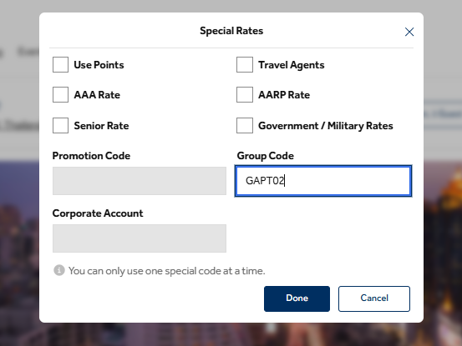
- Click Check Rooms & Rates and input their personal information;

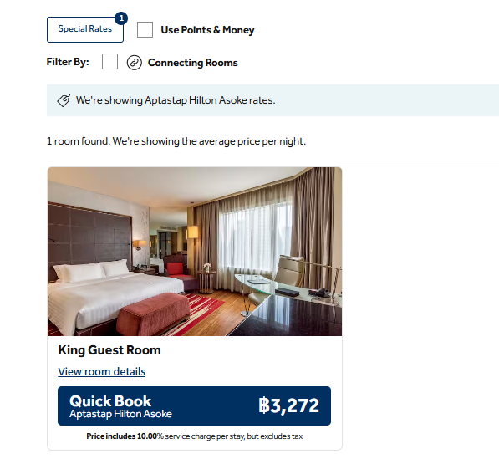
The special group rate per night in website will show room rate ++, however, the final amount for room stay will show in the last page before guest put credit card.

The above-mentioned types of room are available on a first come first served basis. Participants are recommended to make early reservations in order to get the rooms of their choice.

Check-in time is 14:00 hours; check-out time is 12:00 hours.
All bookings must be secured by a major credit card.

Due to the limited availability of rooms, APT Secretariat may not be able to guarantee hotel reservation and special rates after 31 March 2025.
.

- MEETING WEBSITE, MEETING DOCUMENTS AND CONTRIBUTION GUIDELINES

Related information about the meeting and meeting documents will be available at the APT Website at https://apt.int/Meeting/2025-ASTAP37.

APT members and International/Regional Organizations who wish to submit contribution on the agenda items should prepare their contribution in Microsoft Word and/or PowerPoint, English version and in proper template available over ASTAP-37 website and send it to aptastap@apt.int. The deadline for submission of contributions is 11 April 2025.

- WIRELESS LAN

Internet Access over wireless network will be available during the meeting in all meeting rooms. Participants who attend physically and wish to utilize wireless LAN facility are kindly requested to bring their own laptop computers with Wi-Fi capability.

- TRANSPORTATION FROM THE AIRPORT TO THE HOTEL

Participants are requested to use public transportation facilities of the Suvarnabhumi International Airport, Thailand. For more information, please visit website: http://www.bangkokairportonline.com/.

For your general information, the following transportations are available from Suvarnabhumi International Airport to the Hotel:

- Public Meter Taxi is located on 1st floor of the Arrival Hall, entrance 4 and 7. Fare shown on meter, plus THB 50 surcharge for boarding at the airport.

- Airport Limousine Service, the limousine service to various destinations in the city, is located at the arrival floor of the airport.

- Hotel Limousine:

VEHICLE MODEL | PRICE PER UNIT | MAXIMUM CAPACITY
Toyota Camry | THB 1,800 Nett/ Car/ Way | 3 passengers
Mercedes Benz E-Class | THB 2,800 Nett/ Car/ Way | 3 passengers
Toyota Commuter (Van) | THB 2,500 Nett/ Car/ Way | 8 passengers

It takes about 45 minutes by car from Suvarnabhumi International Airport to the hotel via express way.

- VISA AND IMMIGRATION INFORMATION
Thailand’s visa requirements may vary for the citizens of different countries. Please check the visa requirements with a Royal Thai Embassy or a Royal Thai Consulate-General in your respective country in advance. Kindly visit https://consular.mfa.go.th/th/page/cate-7393-general-information?menu=5d68c88d15e39c160c00827e for more details.
If you require a visa supporting letter from the APT, please contact aptadmin@apt.int.

- INSURANCE

APT will not be able to bear any cost of medical or travel insurance for the participant including any measures for Covid-19 such as quarantine, PCR test, etc. APT requests Administrations/Organizations to kindly make necessary arrangements for medical, travel insurance and others covering the whole period of the event and overseas travel for the participant.

XI. CODE OF CONDUCT

The Code of Conduct requires that all participants in connection with APT meetings or events, whether virtual, hybrid or physical, must observe professional, respectful and responsible conduct at all times, bearing in mind zero tolerance on discrimination or intimidation against cultural, ethnic, religious and gender differences to facilitate a safe and inclusive environment.

More details on APT Code of Conduct are available at: https://apt.int/pdf/view?filename=Guideline-20-APT-Code-of-Conduct-2023.pdf

XII. CONTACT INFORMATION

For any further information about ASTAP-37, please contact:

APT Secretariat
12/49, Soi 5, Chaeng Watthana Road, Lak Si, Bangkok 10210, Thailand
Phone: +66 2 573 0044
Fax: + 66 2 573 7479
Email: aptastap@apt.int

XIII. MAP OF THE HOTEL

https://www.hilton.com/en/hotels/bkkashi-hilton-bangkok-grande-asoke/hotel-location/

Hotel name in Thai language to be shown to taxi driver:

“โรงแรมฮิลตัน กรุงเทพ แกรนด์ อโศก”

Note: Many taxi drivers do not have a clear understanding of English. Therefore, please collect the hotel card and show to the taxi driver on your return to the hotel.

_____________________

