
The 3rd Meeting of the Correspondence Group for the APT Ministerial Meeting 2025 (CGMM-3)

4 - 6 February 2025, Bangkok, Thailand

INFORMATION FOR PARTICIPANTS

The 3rd Meeting of the Correspondence Group for the APT Ministerial Meeting 2025 (CGMM-3) is scheduled to be held from 4 to 6 February 2025 at the APT Headquarters in Bangkok, Thailand. The CGMM-3 will be conducted in a hybrid format, allowing for both physical and online/virtual participation. Please find the following information for the convenience of the participants.

- VENUE

The Meeting will be held at APT Headquarters, Bangkok, Thailand. The contact details of the APT Secretariat are as follows:

ASIA-PACIFIC TELECOMMUNITY
Address: 12/49 Soi 5, Chaeng Watthana Road, Lak Si, Bangkok 10210, Thailand
Telephone: +66 2 5730044
Telefax: +66 2 5737479
E-mail: aptcgmm@apt.int

- PARTICIPATION

APT Members and Associate Members may participate in the work of CGMM. APT Affiliate Members may participate as an observer. The Chair of the CGMM may invite non-Members to participate in an advisory capacity in consultation with the Secretary General of the APT.

Your administration is kindly requested to register delegates by the date specified in the following section.

Virtual participation will be arranged by using Zoom meeting platform. Detailed information for virtual participation will be sent to the registered delegates.

- REGISTRATION AND NAME BADGES

Registration for both physical and virtual/online participants shall be done by 24 January 2025 at https://www.apt.int/content/online-registration. Please indicate in the registration form whether your delegate will attend in person or virtually. Only the registered participants are entitled to join the meeting.

The registration desk will be located outside the meeting room. Participations are required to bring their passports or other photo identification to receive their badges.

Virtual participation will be arranged by using Zoom meeting platform. Detail information for virtual participation will be sent to the registered delegates who wish to attend virtually.

- HOTEL ACCOMMODATION AND RESERVATION

The following hotels are recommended for participants to stay during the Meeting.

4.1 Centara Life Government Complex Hotel & Convention Centre Chaeng Watthana

Address: 120 Mu 3 Convention Centre Building,
The Government Complex B.E. 2550 Chaeng Watthana Road,
Laksi Bangkok 10210, Thailand

Telephone: +66 (0) 2143 1234

Contact Reservation Department
Tel 66(0)2-143-1234 # 8184 Fax 66(0)2-143-1239
Email rsvncgc@chr.co.th

Website: https://www.centarahotelsresorts.com/centra/cgc

The rates are:

Room Type | Room Rate
Centra Superior Single | THB 1,800 net/room/night  (included breakfast and internet access)
Centra Superior Twin | THB 2,000 net/room/night  (included breakfast and internet access)
Centra Deluxe Single | THB 2,200 net/room/night  (included breakfast and internet access)
Centra Deluxe Twin | THB 2,500 net/room/night  (included breakfast and internet access)
*The price is net inclusive of 10% service charge and 7% VAT

Please send the Hotel Reservation form to e-mail address: rsvncgc@chr.co.th with a copy to warrawan@apt.int.

Please double-click the below hotel reservation form of the Centara Life Government Complex Hotel & Convention Centre Chaeng Watthana. Cancellation and no-show policies are as stated in the hotel reservation form.

Round trip transportation from the Centra Government Complex to the APT Headquarters will be provided by the hotel.

In order to be eligible for the special rates given above, please make your hotel booking at the earliest possible date.

4.2 Centara Grand at Central Plaza Ladprao Bangkok

Address: 1695 Phaholyothin Road, Chatuchak, Bangkok 10900, Thailand
Telephone: +66 2 5411234
Website: https://www.centarahotelsresorts.com/centaragrand/cglb
E-mail: anusarang@chr.co.th
(Ms. Anusara Ngamsriviroj, Senior Sales Manager)

The rates are:

Room Type | Room Rate
Deluxe Room (King/Twin) | THB 3,350 net/room/night  (included breakfast and internet access)
Premium Deluxe (King/Twin) | THB 3,650 net/room/night  (included breakfast and internet access)
*The prices are net inclusive of 10% service charge and 7% VAT

For hotel reservation at Centara Grand at Central Plaza Ladprao, please send the hotel reservation form to e-mail address: anusarang@chr.co.th with a copy to APT Secretariat, warrawan@apt.int.

Please double-click the below hotel reservation form of the Centara Grand at Central Plaza Ladprao.

Please be advised that participants staying at the Centara Grand at Central Plaza Ladprao are requested to arrange their own transportation (own expense) from the hotel to the APT Headquarters and return back to the hotel. Cancellation and no-show policies are as stated in the hotel reservation form.

The options of transportation from Centara Grand at Central Plaza Ladprao to the APT Headquarters are as follows.

1. Taxi meter: approximately 150-200 baht, 30-60 minutes (depending on the traffic).
2. Subway (MRT Blue Line): From Phahon Yothin Station to Bang Sue station and change to Sky Train (SRT Dark Red Line) to Laksi Station. Then walk around 5-7 minutes to the APT HQ.
3. Sky Train (BTS Green Line): From Ha Yaek Lat Phrao (Lat Phrao Intersection) Station to Wat Phra Sri Mahathat station and change to MRT Pink line to National Telecom (NT) station. Then walk around 5 minutes to the APT HQ.

Subway and Sky Train lines map can be found in this link; . https://www.bangkoktransitmap.com/

4.3 TK. Palace Hotel & Convention
Address: 54/7 Cheangwattana Rd., Soi 15 Laksi ,Bangkok ,10210 Thailand
Telephone: 66(2) 574-1588 Fax 66(2) 574-2622
E-mail: Aomthip.za@gmail.com

The rates are:

Room Type | Room Rate
Superior Single room | THB 1,600 net/room/night  (included breakfast and internet access)
Superior Twin room | THB 1,800 net/room/night  (included breakfast and internet access)
*The prices are net inclusive of 10% service charge and 7% VAT

For hotel reservation at TK. Palace Hotel & Convention, please send the hotel reservation form to e-mail address: Aomthip.za@gmail.com with a copy to APT Secretariat, warrawan@apt.int.

Please double-click the below hotel reservation form of the TK. Palace Hotel & Convention.

The location of the TK. Palace Hotel & Convention, please click this link; https://www.tkpalace.com/location-hotel-bangkok

Due to the limited availability of rooms, APT Secretariat may not be able to guarantee hotel reservation and special rates for the above recommended hotels. Please make your hotel reservation as early as possible.

- MEETING WEBSITE, MEETING DOCUMENTS AND CONTRIBUTION GUIDELINES

Related information about the meetings and meeting documents will be available at the APT Website at https://apt.int/Meeting/2025-CGMM3.

- TRANSPORTATION FROM THE AIRPORT TO THE HOTEL

Physical participants are requested to use public transportation facilities of the Suvarnabhumi International Airport, Thailand. For more information, please visit website: http://www.bangkokairportonline.com/.

For your general information, the following transportations are available from Suvarnabhumi International Airport to the Hotel:

- Public Meter Taxi is located on 1st floor of the Arrival Hall, entrance 4 and 7. Fare shown on meter, plus THB 50 surcharge for boarding at the airport.

- Airport Limousine Service, the limousine service to various destinations in the city, is located at the arrival floor of the airport.

- Hotel Limousine: Please contact the hotels directly.

It takes about 50 minutes by car from Suvarnabhumi International Airport to the hotels via express way.

- VISA AND IMMIGRATION INFORMATION
Thailand’s visa requirements may vary for the citizens of different countries. Please check the visa requirements with a Royal Thai Embassy or a Royal Thai Consulate-General in your respective country in advance. Kindly visit https://consular.mfa.go.th/th/page/cate-7393-general-information?menu=5d68c88d15e39c160c00827e for more details.
If you require a visa supporting letter from the APT, please contact aptadmin@apt.int.

- INSURANCE

APT will not be able to bear any cost of medical or travel insurance for the participant including any measures for Covid-19 such as quarantine, PCR test, etc. APT requests Administrations/Organizations to kindly make necessary arrangements for medical, travel insurance and others covering the whole period of the event and overseas travel for the participant.

- CODE OF CONDUCT

The Code of Conduct requires that all participants in connection with APT meetings or events, whether virtual, hybrid or physical, must observe professional, respectful and responsible conduct at all times, bearing in mind zero tolerance on discrimination or intimidation against cultural, ethnic, religious and gender differences to facilitate a safe and inclusive environment.

More details on APT Code of Conduct are available at: https://www.apt.int/sites/default/files/Upload-files/GA-MC-DOCS/APT-Code-of-Conduct.pdf

- PRACTICAL INFORMATION

Bangkok: There are a great variety of tourist places in Bangkok, mostly historical attractions and temples with elaborate architecture and art. Famous temples are Wat Phra Kaew, Wat Pho, Wat Arun, Wat Phu Khao Thong, Wat Ratchanadda, Wat Traimit, Wat Benchamabophit, Wat Bowon, and Wat Sutat.

There are also palaces, museums, parks, and a big array of shopping places, from luxury malls to flea and street markets like Chatuchak Weekend Market, Sampeng Market, and Pahurat Textile Market. Bangkok nightlife is another highlight that has attracted many of tourists from all over the world.

Bangkok is also surrounded by many interesting provinces worth visiting.
- North - borders Nonthaburi and Pathum Thani Provinces, with tourist attractions like Koh Kret and Lotus Museum.
- East - is next to Chachoengsao, a small province which is full of interesting places and activities. Tourists can pay homage to Luang Pho Sothon Buddha Image at Wat Sothon Wararam Worawihan, watch flying foxes or fruit bats at Wat Pho, see the golden church at Wat Paknam Jolo, and pray to the giant reclining Ganesh statue at Wat Saman Rattanaram. There are also old markets for you to visit and shop such as Ban Mai Market, Nakhon Nuang Khet Market, and Khlong Suan Market.
- South - borders Samut Prakan Province and the Gulf of Thailand, with tourist attractions like Bang Pu, Ancient City, and Samut Prakan Crocodile Farm and Zoo.
- West - is next to Samut Sakhon and Nakhon Pathom Provinces. Tourist attractions include Don Kai Dee Benjarong Village, Phra Pathom Chedi, Sanam Chandra Palace, Don Wai Floating Market, Sampran Riverside, and Thai Human Imagery Museum.

Weather: Average temperature in February is between 30 and 35 degree Celsius.
Time Zone: GMT + 7 hours.
Banks & Currency: The unit of Thai currency is Thai Baht (THB). The UN exchange rate as of June 2023 is THB 34.56 to USD 1.
Electricity: Supply voltage is 220V, 50Hz. A standard grounded Thai outlet supports European 2-pin plugs and earthed and unearthed American plugs (see picture). Please bring the right adapter for your equipment.

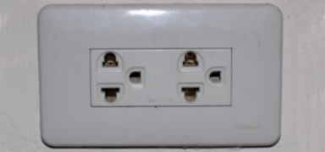

- CONTACT INFORMATION:

APT Secretariat
Asia Pacific Telecommunity (APT)
12/49 Soi 5 Chaeng Watthana Road
Bangkok 10210, Thailand
Telephone: +66 2 5730044
Telefax: +66 2 5737479
E-mail: aptcgmm@apt.int

- MAPS:

MAP TO APT HEADQUARTERS

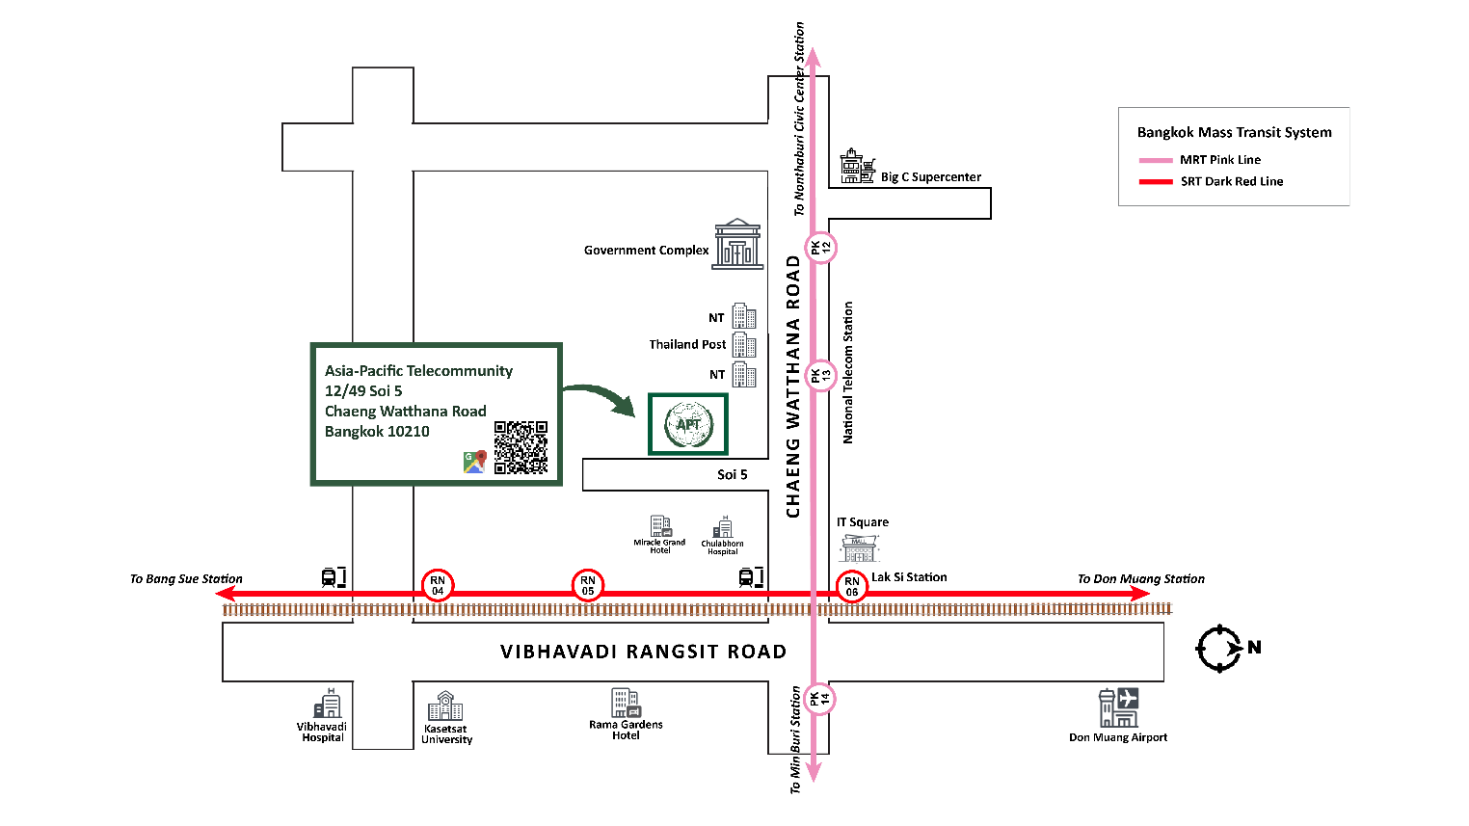

Map to Centara Life Government Complex Hotel & Convention Centre Chaeng Watthana
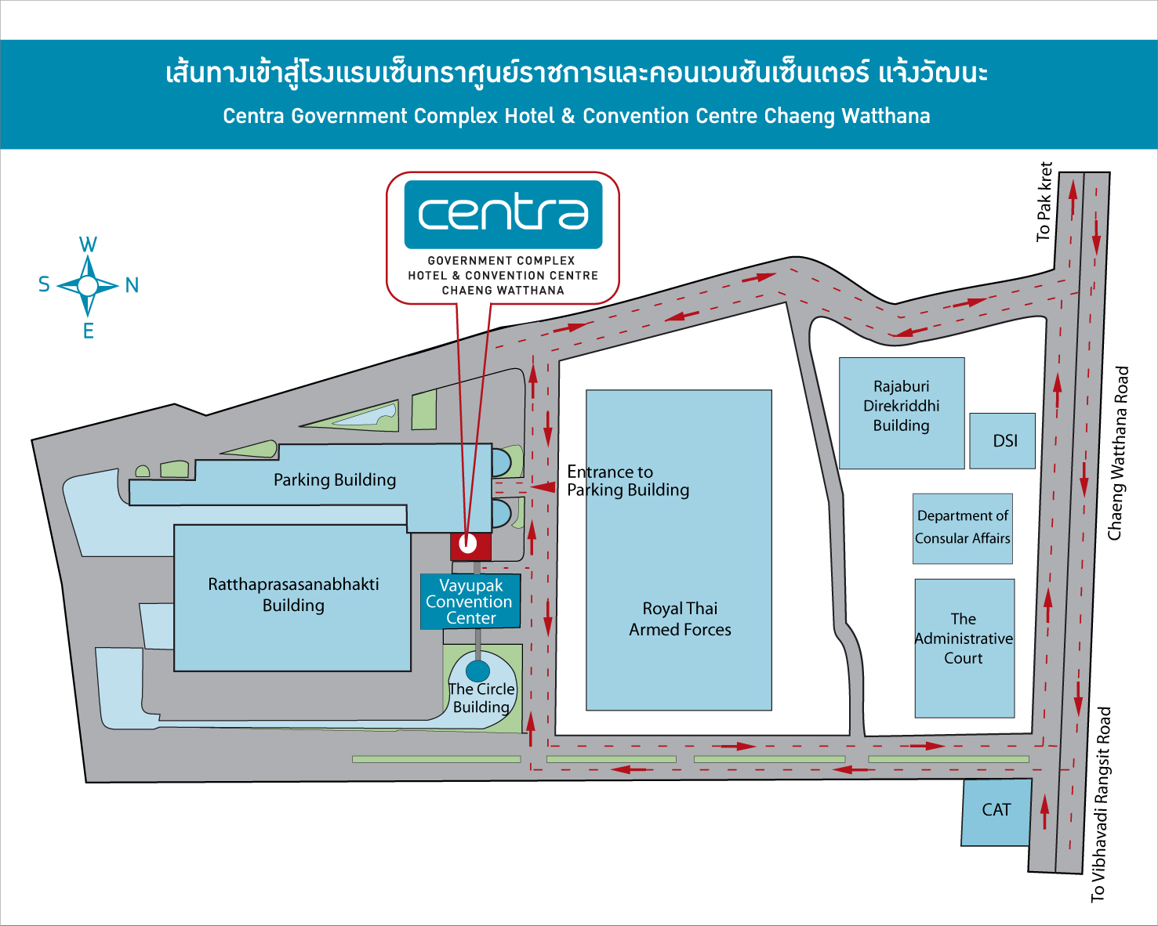
NT

MAP TO CENTARA GRAND AT CENTRAL PLAZA LADPRAO BANGKOK
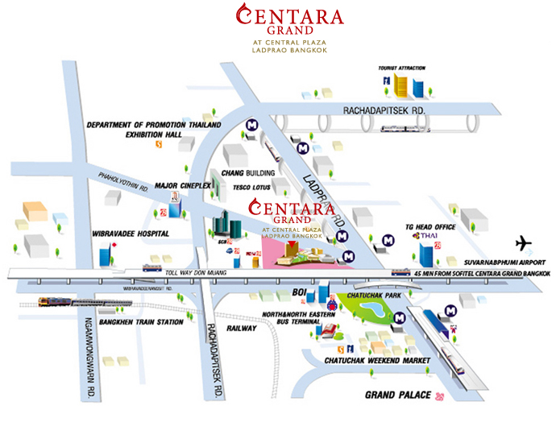

Source: Tourism Authority of Thailand

