 | The 3rd Meeting of the APT Preparatory Group  for WTDC-25 (APT WTDC25-3)  17 - 18 March 2025, Bangkok, Thailand | 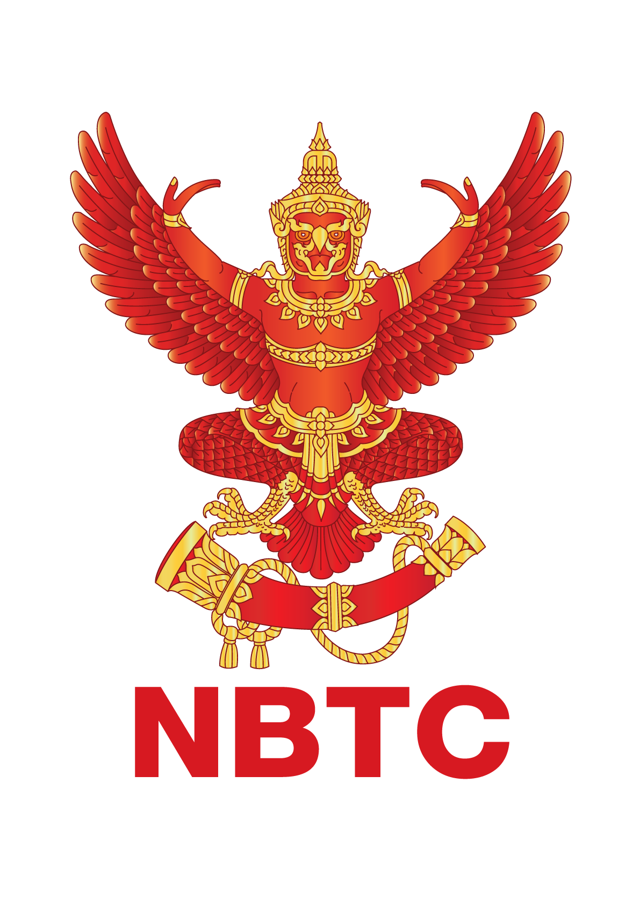

INFORMATION FOR PARTICIPANTS

The 3rd Meeting of the APT Preparatory Group for WTDC-25 (APT WTDC25-3) is scheduled to be held from 17 to 18 March 2025, Bangkok, Thailand with physical attendance as well as virtual/online participation through Zoom meeting platform (i.e., hybrid meeting). The event will be organized by the Asia-Pacific Telecommunity (APT) and hosted by the National Broadcasting and Telecommunication Commission (NBTC), Thailand.

Please find the following information for the convenience of participants.

- MEETING VENUE

The APT WTDC25-3 will be held at Eastin Grand Hotel Sathorn. The contact details of the hotel are as follows:

Eastin Grand Hotel Sathorn
Address: 33/1 South Sathorn Road, Yannawa, Sathorn, Bangkok 10120 THALAND
Phone: +66 2210 8100
Email: adoce@eastingrandsathorn.com
URL: www.eastingrandsathorn.com

- PARTICIPATION

All APT Members, Associate Members and Affiliate Members may participate in the activities of the APT-WTDC. Organizations which have a Memorandum of Understanding (MoU) with the APT or other relevant international or regional organizations may send representatives to attend APT-WTDC meetings on the same basis as they attend other APT meetings.

Non-APT members may be invited to participate in the activities of APT-WTDC as guests at the discretion of the Chair and the Secretary General in consultation with the relevant Administration, as appropriate. Other non-APT members may participate with the observer status with the payment of the relevant participation fee at the discretion of the Chair and the Secretary General in consultation with the relevant Member Administration, as appropriate.

- REGISTRATION

For both physical and virtual/online attendance, registration can be done online at https://www.apt.int/content/online-registration by 28 February 2025 for making necessary arrangements. Please indicate the mode of delegates’ participation at the online registration form. Only the registered participants are entitled to attend the meeting.

- HOTEL ACCOMMODATION AND RESERVATION

The following hotels are recommended for the accommodation of the delegates during the
meeting:

  - Eastin Grand Hotel Sathorn (Recommended Accommodation)
Address: 33/1 South Sathorn Road, Yannawa, Sathorn, Bangkok 10120 THALAND
Phone: +66 2210 8100
Email: rsvn@eastingrandsathorn.com
Location: https://maps.app.goo.gl/wmGiuY11Nmo5T5NX7
URL: https://forms.office.com/r/CKFTRP8pfF

Room Type | Room Rate / Night |  | Deadline of Reservation
Room Type | Single | Double/Twin | Deadline of Reservation
Superior | Baht 3,800 net | Baht 3,800 net | 1 March 2025
Check in time : 14.00 hrs
The above rates are inclusive of 10% service charge, 7% government tax and all non-commissionable.

VALUED-ADDED SERVICE;
    - Daily international buffet breakfast
    - Wireless internet access in room and public area
    - Complimentary bottled drinking water (2 bottles per day)
    - Complimentary coffee and tea set in room
    - Pool and gym facilities access

CHECK IN & CHECK OUT TIME:
    - Check-in time is 14:00 hrs. of arrival date and check-out time is 12:00 hrs. of
departure date.
    - For early check-in, late checkout and/or extension of stay are subject to availability.

GUARANTEE POLICY
    - All reservations require a credit card guarantee at the time of booking.

CANCELLATION POLICY
    - Reservations must be cancelled by 6 pm on the arrival date to avoid a penalty charge of 1 night’s stay plus tax.
    - Non-arrival (No-show) will be subject to a 100% charge for the first room night.

  - Mode Sathorn Hotel Bangkok (Alternative Accommodation)
Address: 144, North Sathorn Road, Silom, Bangrak, Bangkok, 10500, Thailand Phone: 02 623-4555
Email: jae@modesathorn.com
URL: www.modesathorn.com
Location: https://maps.app.goo.gl/a3Wf77vvNU9eu3U1A

Room Type | Room Rate / Night |  | Deadline of  Reservation
Room Type | Single | Double/Twin | Deadline of  Reservation
Deluxe Room | Baht 3,500 net | Baht 3,500 net | 15 March 2025
Check in time : 15.00 hrs
The above rates are inclusive of 10% service charge, 7% government tax and all non-commissionable.

  - Holiday Inn Express Bangkok Sathorn (Alternative Accommodation)
Address: 51 Soi Pipat Bangkok, 10500 Thailand
Phone: +662 660 2800, 081 425 6165
Email:
info.bkkbt@ihg.com
nutchanart.salimin@ihg.com
thamonwan.mueanjunchoey@ihg.com

URL:
https://www.ihg.com/holidayinnexpress/hotels/th/th/bangkok/bkkbt/hoteldetail
Location: https://maps.app.goo.gl/8rAt9BjfmSq7vA7b9

Room Type | Room Rate / Night |  | Deadline of Reservation
Room Type | Single | Double/Twin | Deadline of Reservation
Standard Room | Baht 2,100 net | Baht 2,100 net | 28 February 2025
Check in time : 15.00 hrs
The above rates are inclusive of 10% service charge, 7% government tax and all non-commissionable.

- MEETING WEBSITE, MEETING DOCUMENTS AND CONTRIBUTION GUIDELINES

Related information about the meeting and provisional meeting documents will be available at the APT Website: https://apt.int/Meeting/2025-WTDC25-3.

APT members and International/Regional Organizations who wish to submit contributions on the agenda items, should prepare their contribution(s) in Microsoft Word and/or PowerPoint, English version and in proper template provided by APT Secretariat and send it to aptwtdc@apt.int. The template is available on APT website at: https://apt.int/event/download/document/34135. The deadline for submission of contributions is 6 March 2025. Contributions will be posted on APT Website prior to the start of the meeting.

- CODE OF CONDUCT

The Code of Conduct requires that all participants in connection with APT meetings or events, whether virtual, hybrid or physical, must observe professional, respectful and responsible conduct at all times, bearing in mind zero tolerance on discrimination or intimidation against cultural, ethnic, religious and gender differences to facilitate a safe and inclusive environment.

More details on APT Code of Conduct are available at:
https://apt.int/sites/default/files/file_tag/2023/11/APT-Code-of-Conduct.pdf

- WIFI

Internet Access over Wi-Fi network will be available during the meeting. Participants who attend physically and wish to utilize Wi-Fi Internet facility are kindly requested to bring their own laptop computers/devices with Wi-Fi capability.

- TRANSPORTATION FROM THE AIRPORT TO THE HOTEL

Physical participants are requested to use public transportation facilities of the Suvarnabhumi
International Airport, Thailand. For more information, please visit website: http://www.bangkokairportonline.com/.

For your general information, the following means of transportation are available from
Suvarnabhumi International Airport to the Hotel:

- Public Meter Taxi is located on 1st floor of the Arrival Hall, entrance 4 and 7. Fare shown on meter, plus THB 50 surcharge for boarding at the airport.

- Airport Limousine Service, the limousine service to various destinations in the city, is located at the arrival floor of the airport.

- Hotel Limousine (Rate from Eastin Grand Hotel Sathorn)

Toyota Camry Baht 1,950 net/way/car
(Maximum 2 persons and 2 medium-sized pieces of luggage)

Toyota Commuter Van Baht 2,500 net/way/car
(Maximum 7 persons and 7 medium-sized pieces of luggage)

** The above prices are inclusive of 10% service charge and 7% government tax. In the event of changes to government taxes (+/-), rates will be adjusted accordingly to reflect changes.

It takes about 40 minutes by car from Suvarnabhumi International Airport to the hotel via express way.

- VISA AND IMMIGRATION INFORMATION
Thailand’s visa requirements may vary for the citizens of different countries. Please check the visa requirements with a Royal Thai Embassy or a Royal Thai Consulate-General in your
respective country in advance. Kindly visit https://consular.mfa.go.th/th/page/cate-7393-general-information?menu=5d68c88d15e39c160c00827e for more details.
If you require a visa supporting letter from the APT, please contact aptadmin@apt.int.

- INSURANCE

APT will not be able to bear any cost of medical or travel insurance for the participant including any measures for Covid-19 such as quarantine, PCR test, etc. APT requests Administrations/Organizations to kindly make necessary arrangements for medical, travel insurance and others covering the whole period of the event and overseas travel for the participant.

- PRACTICAL INFORMATION

About Thailand:
Official Name: Kingdom of Thailand
Population: 71.8 million
Capital City: Bangkok
Area: 513,120 km²
Religion: Buddhism
Language: Thai
International dialing code: +66

Weather:
The country has a tropical climate: warm and humid. In the monsoon season from July to October, abundant rain allows for the cultivation of a wide variety of crops. The most pleasant season is from November to early April. However, the climate varies throughout the country, and you can visit all year round. In the south, the climate differs between the eastern and western coasts.

Time Zone: GMT +7 hours

Banks & Currency:
Thai Baht (THB) is the official currency. The exchange rate as of 8 January 2025 is THB 34.64 to USD 1. Automated Teller Machines (ATM) (cash dispenser) are available everywhere in the city (Visa, MasterCard). Banks are usually open from 09:00 to 15:30 hours from Monday to Friday.

- MAP OF THE HOTEL

For map of Eastin Grand Hotel Sathorn hotel: please click the link below:

[https://maps.app.goo.gl/wmGiuY11Nmo5T5NX7]

Hotel name in Thai language to be shown to taxi driver:

“<<โรงแรมอีสติน แกรนด์ สาทร>>”

Note: Many taxi drivers do not have a clear understanding of English. Therefore, please collect the hotel card and show to the taxi driver on your return to the hotel.

- CONTACT INFORMATION

APT Secretariat  Asia-Pacific Telecommunity (APT)  12/49 Soi 5 Chaeng Watthana Road  Bangkok 10210, Thailand  Phone: +66 2 573 0044  Fax: +66 2 573 7479  Email: aptwtdc@apt.int | Local Secretariat  Ms. Kanlayapat Kaewvejchabutr  Mid Level Policy and Planning Officer  International Affairs Bureau  Office of the National Broadcasting and Telecommunications Commission (NBTC)  Phone: +66 2 670 8888 ext. 3522  Email: kanlayapat.k@nbtc.go.th

