 | The Meeting of the SATRC Working Group  on Policy, Regulation and Services  18 –19 April 2017, Dhaka, Bangladesh | 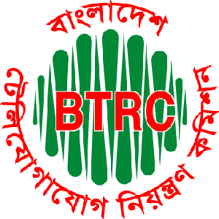

INFORMATION FOR PARTICIPANTS

The Meeting of the SATRC Working Group on Policy, Regulation and Services will be held from 18 to 19 April 2017 in Dhaka, Bangladesh. The meeting will be organized by the Asia-Pacific Telecommunity (APT) and hosted by Bangladesh Telecommunication Regulatory Commission (BTRC).
The information below will be useful for the participants.

- Venue

Bangladesh Telecommunication Regulatory Commission (BTRC)
Institute of Engineers Bangladesh (IEB) Bhaban (7th Floor)
Ramna, Dhaka-1000
Tel.: +88 02 9611111
Fax: +88 02 9556677
Website: http://www.btrc.gov.bd

- Participation

All SATRC Members and Affiliate Members from SATRC countries can attend the meeting free of charge.

- Registration

Registration of delegates can be done online at http://www.apt.int/content/online-registration. In order to take preparation and making logistic arrangements it is suggested to register on or before 18 March 2017.

- Hotel Accommodation

For the convenience of the participants, all the participants shall stay near the venue area. The hotels recommended below for the accommodation of delegates. The room rates below are inclusive of breakfast. The details of the hotel are:-

Name of the Hotel | Room Type | Room Rate
Four Points by Sheraton  6/A North Avenue C/A, Gulshan 2,  Dhaka-1212, Bangladesh  Email: Rezwanul.Alam@fourpoints.com  Website: www.fourpoints.com/DHAKAGULSHAN | Deluxe Room  Premier Room | USD 110++  USD 130++

Note:
- The prices are subject to availability and subject to change
- Airport pick-up will be arrange by the local host upon prior intimation and the only for the recommended hotels.

- Meeting Website, Meeting Documents and Contribution Guideline

Related information about the meeting and provisional meeting documents will be available at the APT Website: http://www.apt.int/APTSATRC.

Contributions for the meeting from SATRC Members, Affiliate Members from SATRC countries, regional and international organizations are welcome. You are requested to use the proper document template for your contribution. For any information on the documentation please contact:

Mr. Forhadul Parvez
Project Coordinator, Radiocommunication
Tel.: +66 2 573 0044 (Ext: 117)
E-mail: parvez@apt.int

APT encourages the use of electronic documents during the meeting. Members are encouraged to carry their laptop computers for the meeting.

- Visa and Immigration Requirements

Delegates are strongly advised to check all entry and visa requirements on the websites of Bangladeshi Embassies and High Commissions. Visa supporting letter can be issued on request. Please submit the following information along with a copy of passport to local secretariat coordinator for the visa supporting letter.

Invitation letters will be issued upon request to assist delegates with the visa process. Delegates who require this assistance and also on-arrival visa should submit the following details at least one (1) month prior to the event to host and APT’s designated points of contact:

- A copy of the passport or full name as written on Passport
- Date and Place of Birth
- Passport number
- Date of Passport issuance
- Date of Passport expiration
- Nationality
- Date of Arrival
- Date of Departure
- Hotel Booking
- Funding
- A valid email address

- Bangladesh: A Brief Profile

Bangladesh is located in Southern Asia, bordered by India to the north, west and east, Myanmar to the southeast and the Bay of Bengal to the south. The country’s total land area is 143,998 sq. km and occupies one of the largest river deltas in the world. Its topography is comprised of fertile alluvial plains and an extensive network of rivers. The country became a sovereign nation in 1971. Bangladesh is a secular parliamentary republic with an elected parliament. Bangladesh is among the most densely populated countries in the world with over 155 million people. Bangla is the mother tongue and English is widely spoken. The majority of the population are Muslim (around 88%), with the remaining a mixture of Christian, Buddhist and Hindu. Administratively, Bangladesh is divided into 7 Divisions and 64 Districts. Dhaka is the capital and largest city of the country. It is historically famous and one the oldest cities of the region.

- Weather

The weather in April is generally hot and humid with little chance of rain. The average temperature in Dhaka in April is 28 °C and it may increase up to 34°C.

- Language

Bangla is the official language but English is widely spoken.

- Time Zone

GMT + 6.00 hours

- Banks & Currency

The unit of currency is Bangladeshi Taka (BDT).Foreign Exchange Rate is approximately BDT 81.0 to US$ 1. Normal banking hours are from 10.00 to 15.00 on week days (Friday & Saturday are closed). Credit cards including American Express, Visa and Master Cards etc. are accepted in major hotels, shops and restaurants.

- Electricity

220 Volts AC 50Hz rating usually used in Bangladesh. The power sockets generally available in Bangladesh are the "Type G" British BS-1363, "Type D" Indian 5 amp BS-546 (round) and BS 4573 (UK shaver). It is advisable to come along with Global adaptors.

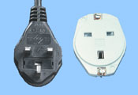

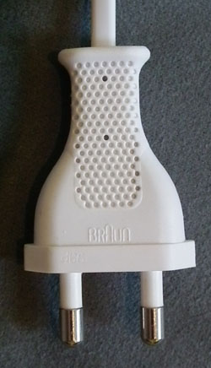

- Arrival and Transportation

Hazrat Shahjalal International Airport is less than 20-30 minutes away from the recommended hotel. The venue of the meeting is around 30 min from the hotel. Airport pick-up is available upon prior intimation to hotel/local host.

- Insurance

Due to procedural difficulties and budgetary constraints, APT is not able to bear the cost of insurance for the participants, any medical expenses or any other expenses. APT therefore requests your Administrations/organizations to kindly make necessary arrangements for insurance and medical coverage of your participants before travel.

- Contact Information

APT Secretariat  Mr. Forhadul Parvez  Project Coordinator, Radiocommunication  Asia-Pacific Telecommunity  12/49 Soi:5 Chaeng Watthana Road  Bangkok 10210, Thailand  Tel.: +66 2 573 0044 (Ext.:117)  Fax: +66 2 573 7479  E-mail: aptsatrc@apt.int | Local Secretariat  For attendance, participation, visa support letter etc.  - Lt. Col. Mohammad Zulfikar, psc  Director, Systems & Services, Division  Bangladesh Telecommunication Regulatory Commission (BTRC)  Tel.: +88 096 11111 Ext.410  Mobile: +88 015 52202725  Email: dirss@btrc.gov.bd  - Aftab Md. Rashedul Wadud  Director, Administration Division  Bangladesh Telecommunication Regulatory Commission (BTRC)  Tel.: +88 096 11111 Ext.210  Mobile: +88 015 52202716  Fax: +88 029 556677  Email: rwadud@btrc.gov.bd

