
The 5th Meeting of the APT Conference Preparatory Group for WRC-15 (APG15-5)
27 July - 1 August 2015, Seoul, Republic of Korea

PARTICIPANT’S INFORMATION

The 5th Meeting of the APT Conference Preparatory Group for the WRC-15 (APG15-5) will be held from 27th of July to 1st of August 2015 in Seoul, Republic of Korea. The meeting will be organized by the Asia-Pacific Telecommunity (APT) and hosted by the Ministry of Science, ICT and Future Planning of the government of the Republic of Korea.

The detailed arrangements are as follows:

VENUE:

Hotel: Millennium Seoul Hilton HOTEL
Address: 50, Sowol-Ro, Jung-Gu, Seoul, 100-802, South Korea
Phone: +82 2 753 7788
Fax: +82 2 754 2510
URL: http://www3.hilton.com/en/hotels/south-korea/millennium-seoul-hilton-SELHITW/index.html

PARTICIPATION:

All APT Members, Associate Members, Affiliate Members and International/Regional Organizations can attend the meeting by registering online. Member Administrations and International/Regional Organizations are requested to send the official List of Delegations for the meeting and to nominate Head of Delegation (HoD) and Alternate HoD. If any APT Affiliate Member is included in the National Delegation, please clearly mention in the List of Delegation.

Participation of Non-Members: Non-Members can attend the meeting with “Observer” status by paying Registration Fee of USD $250 per person. Non-Member participants under National Delegation are exempted from paying the Registration Fee upon submission of a letter of nomination signed by the responsible officer of the Administration. Above requirement does not apply to the host country participation. Please contact APT Secretariat for the payment methods of the Registration Fees.

REGISTRATION:

Registration of delegates can be done online at http://www.apt.int/content/online-registration. In order to take preparation and making logistic arrangements it is suggested to register on or before 29th of June, 2015. For those who need visa to travel to Republic of Korea, the host will provide a visa supporting documentation (Letter of Invitation). For the visa assistance, please fill in the “Visa Supporting Letter Form” in Annex III and submit to local secretariat before 22 June 2015. For more information, please see the ‘Visa and Immigration Information’ in page 5

HOTEL INFORMATION:

1. Millennium Seoul Hilton HOTEL (Venue Hotel with special rates)

Millennium Seoul Hilton HOTEL is recommended for all participants to stay during the meeting. Please make your hotel booking in order to be eligible for the special rates given below at the earliest possible date or no later than 29th of June, 2015.

Please send the Hotel Reservation form directly to the hotel; e-mail address: reservations.seoulmillennium@hilton.com or Tel : +82-2-317-3000 (Mr. Steve Uhm)

< Millennium Seoul Hilton HOTEL for APG15-5 Rates >
Room Type | Rate | Description
Deluxe Single | KRW 193,600 | Breakfast NOT included
Deluxe Single | KRW 223,850 | 1 Breakfast included
Deluxe Twin | KRW 223,850 | Breakfast NOT included
Deluxe Twin | KRW 254,100 | 2 Breakfast included

Accommodation rates quoted are:
- All rates are tax-inclusive
- All rooms with free Wi-Fi service
- Please see the hotel reservation form enclosed to this for detailed information

* Please note that the local secretariat is NOT responsible for the hotel reservation and participants are encouraged to make the reservation as early as possible

2. Fraser Place Namdaemun HOTEL (Sub Hotel with special rates)

Fraser Place Namdaemun HOTEL is recommended for all participants to stay during the
Meeting. Please make your hotel booking in order to be eligible for the special rates given
below at the earliest possible date or no later than 29th of June, 2015.

Please send the Hotel Reservation form directly to the hotel; e-mail address: reservations.namdaemun@frasershospitality.com or Tel : +82-2-2220-8000(Mr. Joseph Jeon)

< Fraser Place Namdaemun HOTEL for APG15-5 Rates >

Room Type | Rate | Description
Superior | KRW 151,800 | 1 Breakfast included
Superior Twin | KRW 165,000 | 2 Breakfast included
Deluxe | KRW 176,000 | 1 Breakfast included
Premier | KRW 192,500 | 1 Breakfast included
Premier Twin | KRW 205,700 | 2 Breakfast included

Accommodation rates quoted are:
- All rates are tax-inclusive
- All rooms with free Wi-Fi service
- Please see the hotel reservation form enclosed to this for detailed information

* Please note that the local secretariat is NOT responsible for the hotel reservation and participants are encouraged to make the reservation as early as possible
* The hotel is located within 11 to 15 minutes walking distance (about 729 m)

3. RAMADA Hotel & Suites (Sub Hotel with special rates)

RAMADA Hotel & Suites is recommended for all participants to stay during the meeting.
Please make your hotel booking in order to be eligible for the special rates given below at
earliest possible date or no later than 29th of June, 2015.

Please send the Hotel Reservation form directly to the hotel; e-mail address: rsvn@ramadapnp.com or Tel: +82-2-2119-8900 (Mr. Harrison Choi)

< Ramada Hotel & Suite for APG15-5 Rates >

Room Type | Rate | Description
Superior | KRW 133,100 | Breakfast NOT included
Superior Twin | KRW 133,100 | Breakfast NOT included
Deluxe | KRW 157,300 | Breakfast NOT included
Deluxe Twin | KRW 157,300 | Breakfast NOT included

* Breakfast is available with extra charge of KRW 15,730 each person

Accommodation rates quoted are:
- All rates are tax-inclusive
- All rooms with free Wi-Fi service
- Please see the hotel reservation form enclosed to this for detailed information

* Please note that the local secretariat is NOT responsible for the hotel reservation and participants are encouraged to make the reservation as early as possible
* The hotel is located within 15 to 20 minutes walking distance (about 1.08 Km)

MEETING WEBSITE, MEETING DOCUMENTS AND CONTRIBUTION GUIDELINE:

Related information about the meeting and provisional meeting documents will be available at the APT Website at: http://www.apt.int.

Contributions for the meeting from APT Members, Associate Members, Affiliate Members, regional and International Organizations are welcome. You are requested to use the proper document template for your contribution.

Please read the Contribution Guideline for the preparation of your contribution as embedded below.

Contributions will be posted on APT Website prior to the starting of the meeting. Last date of receipt of your contributions by APT Secretariat is July 20, 2015. To submit contributions and any information on the documentation, please contact:

Mr. Forhadul Parvez
Project Coordinator, Radiocommunication
Asia-Pacific Telecommunity
Phone: +66 2 573 0044 (Ext. 117)
E-mail: parvez@apt.int

In order to facilitate efficient meeting management and document handling process, APT encourages the use of electronic documents during the meeting. Electronic copies of the meeting documents will be available on line.

WIRELESS LAN:

Internet Access over wireless network will be available during the meeting. Participants who wish to utilize wireless facility are kindly requested to bring their own laptop computers with Wi-Fi capability.

TRANSPORTATION FROM THE AIRPORT TO THE HOTEL:

For your information, the following transportation options are available from the Incheon Int’l Airport to the Millennium Seoul Hilton HOTEL:

- KAL Limousine Shuttle

KAL limousine shuttle (bus number # 6702) is available only from Incheon airport at KRW 16,000 per person/way visa versa. The shuttle stops at the following designated places;

- Please head to Stop 4B to take the KAL Limousine of Namsan way if you arrive at Gate A / B / C in Incheon Airport.
- Please head to Stop 11A to take the KAL Limousine of Namsan way if you arrive at Gate D / E / F in Incheon Airport.

You can purchase tickets at KAL Limousine counter or from Information desk that is in front of each gate. Please kindly visit KAL limousine official website to reach up-to-date time schedule for further assistance. http://www.kallimousine.com/eng/schedule_en.asp

- Taxi

You are able to grab a public taxi at the right front of the Incheon airport. The fare will be approximately KRW 90,000 depending on traffic jam on the date of arrival.

- AREX Express Train

The train runs at intervals of approximately 5 minutes from 05:20 onwards. You are able to choose either the express train or the commuter train depending on your schedule. The express train takes about 42 minutes and it costs KRW 8,000 per person. The commuter train takes about 53 minutes and it costs KRW 3,950 per person.

< Station map of AREX Express Train >

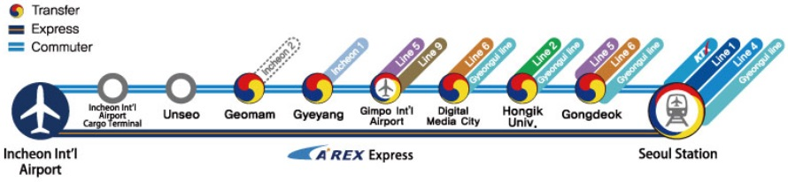

*There is a free shuttle bus operating between Seoul station and the hotel. When you get off the AREX train and exit, you will be able to find the shuttle bus information desk on the 1st floor across exit No.4. The shuttle bus runs at intervals of 1 hour from 8:30 onwards until 19:30. It takes about 10 to 20 minutes to get to the hotel depending on the traffic.

VISA AND IMMIGRATION INFORMATION:

A visa may be necessary for participants from some countries to enter Korea. To check the visa requirements please contact the Korean Embassy in your country. Kindly visit the Ministry of Foreign Affairs at http://www.mofa.go.kr/ENG/visa/application/index.jsp for more details.

Those participants who need the visa-supporting documents for entering Korea are strongly advised to fill out completely the “Visa Supporting Letter Form in Annex III” and to fax or e-mail the form together with a “Copy of your passport (photograph page)” to the contact point below by 22nd of June, 2015. As requirements for visa application in your country change from time to time, please check with your nearest Korea Embassy for your visa requirements before departure. Advance submission of applications is recommended.
For VISA support, please contact at:

Mr. Kang Ok (Jay) Jeon
Manager
Radio Broadcasting Industry Promotion Center
Korea Radio Promotion Association
Phone: +82 2 317 6173
Fax: +82 2 317 6061
Email: jko@rapa.or.kr

WELCOME RECEPTION:

A Welcome Reception will be held in the evening of the first day, Monday 27 July by courtesy of the Ministry of Science, ICT and Future Planning of the government of the Republic of Korea.

INSURANCE:

Due to the procedural difficulties and budgetary constraints, APT and Local Secretariat are not able to bear the cost of insurance for the participants, any medical expenses or any other expenses. APT and Local Secretariat, therefore, request your administrations/organizations to kindly make necessary arrangements for insurance and medical coverage of your participants before travel.

PRACTICAL INFORMATION:

About Seoul: Located at the heart of the Korean Peninsula, Seoul has always been an important strategic point throughout the centuries in terms of defense and the economy, from one kingdom to the next. The three kingdoms of Baekje, Goguryeo, and Silla (BCE 57 – CE 688) all fought over the area that is now Korea’s capital. Indeed, whichever kingdom claimed Seoul became the dominant power. The Joseon Dynasty (1396 – 1910) declared Seoul its capital, a role that Seoul still plays to this day.

Climate: The average temperature in Seoul in July and August is between 23 and 26 degree Celsius. Please take a look at http://web.kma.go.kr/eng/index.jsp

Time Zone: UTC+9 hours

Banks & Currency: The unit of Korean currency is Korean Won (KRW). The exchange rate as of March 2015 is KRW 1,112.50 to 1 USD. Automated teller machines (ATM) are widely accessible throughout Seoul. http://www.keb.co.kr/main/en/?LOCALE_CODE=KO

Electricity: Supply voltage is 220V, 60Hz. Please ensure you bring the correct adapter for your equipment.

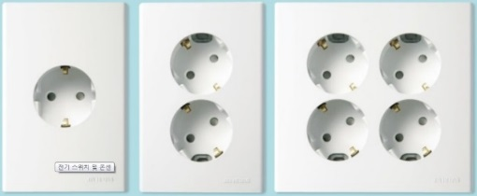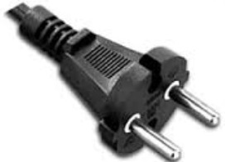
Korean outlet and power cord.

Emergencies: Police 112, Fire Department 119, Medical Emergencies 1339

Business Hours: Government offices are open from Monday to Friday between the hours of 09:00 and 18:00. Most private businesses open anywhere from 08:30 to 22:00. Banks are a major exception. Their business hours are from 09:30 to 16:30 on weekdays. They are closed Saturdays and Sundays. Major departments stores are usually open from 10:30 to 20:00, including Sundays, but smaller shops open earlier and close later every day of the week.

Korea & Korean Tourism: Please visit the following Websites for more information: http://www.visitseoul.net/en/index.do or http://english.seoul.go.kr/

CONTACT INFORMATION:

APT Secretariat  Asia-Pacific Telecommunity  12/49 Soi: 5 Chaengwattana Road  Bangkok 10210, Thailand  Phone: + 66 2 573 0044  Fax: +66 2 573 7479  E-mail: aptapg@apt.int | Korean Secretariat  Korea Radio Promotion Association  3, Mokdongjungang-ro 13na-gil,  Yangcheon-gu, Seoul 158-801, Korea  Phone: + 82 2 317 6173  Fax: +82 2 317 6061  E-mail: jko@rapa.or.kr

ANNEX I

Venue and Hotels Location

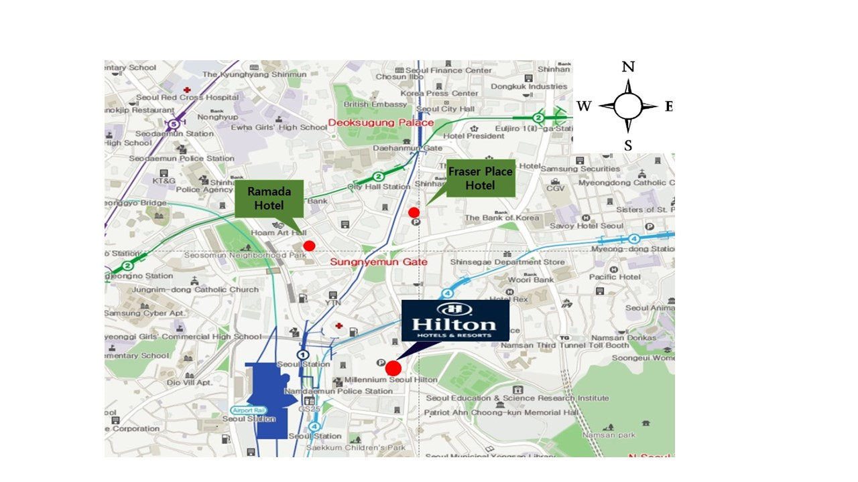

ANNEX II
Hotel Application Form_Hilton Hotel

Korea Radio Promotion Association
In order to secure a room at Millennium Seoul Hilton, please complete to fill out and send to Reservation department.
Reservation |  | Sales Manager Steve Uhm
Tel | :+82 2 317 3000 | Tel | :+82 2 317 3377
Fax | :+82 2 317 3848 | Fax | :+82 2 752 7874
Email | :reservations.seoulmillennium@hilton.com | Email | :steve.uhm@hilton.com

No | Room Type | Special Room Rate | Remarks
1 | Deluxe King (Single Occupancy) | KRW 193,600 | Inclusive of Wi-Fi.
2 | Deluxe King (Double Occupancy) | KRW 223,850 | Inclusive of Wi-Fi.
3 | Deluxe King (Single Occupancy) | KRW 223,850 | Inclusive of Breakfast and Wi-Fi.
4 | Deluxe King (Double Occupancy) | KRW 254,100 | Inclusive of Breakfast and Wi-Fi.
5 | Deluxe Twin (Double Occupancy) | KRW 223,850 | Inclusive of Wi-Fi.
6 | Deluxe Twin (Double Occupancy) | KRW 254,100 | Inclusive of Breakfast and Wi-Fi.

- The above mentioned rates are inclusive of 10% Service charge and 11% VAT.
GUEST INFORMATION
Last Name |  | First Name
Telephone |  | Fax
Nationality |  | Hilton HHonors
E-mail
ROOM REQUIREMENT
Arrival Date |  | Departure Date
Room Type No.
Preferences | Smoking Non-Smoking
CREDIT CARD GUARANTEE
Credit Type | American Express Diners Club MASTER VISA
Credit Number |  |  | Expiry Date |  | /

CUT OFF DATE
Reservation by attendees must be received before 29th of June, 2015. At the cut- off date, Hotel will review the reservation pick-up for the Event, release the unreserved rooms for general sale, and determine whether or not it can accept reservations on a space available basis at Korea Radio Promotion Association rate after this date.

CANCELLATION POLICY
All reservations must be accompanied by a first night room deposit, guaranteed with a major credit card.
Individual cancellations must be made 48 hours prior to arrival in order to avoid charge for the first night’s room and tax.
SIGNED FOR AND ON BEHALF OF :

SIGNATURE DATE ______________________

Hotel Application Form_Fraser Place Namdaemun Hotel

In order to secure a room at Fraser Place Namdaemun Seoul, please complete to fill out and send to Reservation department.
Reservation |  | Sales Manager | : Joseph Jeon
Tel | :+82 2 2220 8000 | Tel | :+82 2 2098 0525
Fax | :+82 2 8880 8208 | Fax | :+82 2 2098 0705
Email | :reservations.namdaemun@frasershospitality.com | Email | :Joseph.jeon@frasershospitality.com
Reservation by attendees must be received before 29th of June, 2015
No. | Room Type | Special Room Rate | Remarks
1 | Superior Double | 151,800 | Inclusive of 1 Breakfast and Wi-Fi.
2 | Superior Twin | 165,000 | Inclusive of 2 Breakfast and Wi-Fi.
3 | Deluxe Double | 176,000 | Inclusive of 1 Breakfast and Wi-Fi.
4 | Premier Double | 192,500 | Inclusive of 1 Breakfast and Wi-Fi.
5 | Premier Twin | 205,700 | Inclusive of 2 Breakfast and Wi-Fi.
- The above mentioned rates are inclusive of 10% VAT.
GUEST INFORMATION
Last Name |  | First Name
Telephone |  | Fax
Nationality |  | E-mail
ROOM REQUIREMENT
Arrival Date |  | Departure Date
Room Type No.
Preferences | Smoking Non-Smoking
CREDIT CARD GUARANTEE
Credit Type | American Express Diners Club MASTER VISA
Credit Number |  |  |  | Expiry Date | /

CUT OFF DATE
- Check in time is after 15:00 and check out is before 12:00 PM
- Complimentary use Fitness center and Sauna
- Complimentary use Shuttle bus from hotel to event venue.
CANCELLATION POLICY

All reservations must be accompanied by a first night room deposit, guaranteed with a major credit card.
- Individual cancellations must be made 48 hours prior to arrival in order to avoid charge for the first night’s room and tax.
_______________________________________
Reservations Taken by: Name / Signature

Hotel Application Form_RAMADA Hotel

--------------------------------------------------------------------------------------------------------------------------
Warm greetings from the Ramada Hotel & Suites Seoul Namdaemun
Please fill out this form and send it back to Ramada Hotel & Suites Seoul Namdaemun by email or fax
Reservation centre: phone +82-2-2119-8900 / fax +82-2-2119-8989 / email rsvn@ramadapnp.com
Person in charge: Harrison Choi / phone +82-2-2119-8957 / fax +82-2119-8918 / email hschoi@ramadapnp.com
--------------------------------------------------------------------------------------------------------------------------
Personal Information
Title / Salutation
First Name/ Last Name
Phone Number
Fax Number
Email Address
Accommodation Information
Room Type | Rate | Remark | Date/Period
Room Type | Rate | Remark | Check in | Check out | Nights
Superior Double | KRW 133,100 | Free WiFi
Superior Twin | KRW 133,100 | Free WiFi
Deluxe Double | KRW 157,300 | Free WiFi
Deluxe Twin | KRW 157,300 | Free WiFi
* The room rates are applicable from July 20 to August 10 2015.
* Attendees must submit registration form to hotel prior to 29th of June, 2015 as room block cut off day.
* All the above room rates are included to 10% of service charge & 11% of V.A.T
*The Breakfast is KRW 15,730 (inclusive all taxes) and will be served at 24th floor at the red square.
* In case of no show, one night charge will be charged on your card.
* Cancellation within 72 hours of arrival will be subject to one night’s charge will be forfeited on your credit card.
* In case of early check in, extra cost will be charged upon a check in time.
* Our check in time is after 15:00 and check out time is 12:00 PM
* Free Shuttle bus from hotel to event venue.
Payment Information

□ Amex □ Diners □ Master □ Visa □ JCB | 4 digit number for AMEX:
Card Number: | Expiry Date:

Please fill out your special request
___________________________________________________________________________

ANNEX III

*Please fill in the following form and attach a copy of passport to get support on your visa application. Please be informed that this is NOT THE REGISTRATION FORM. Registration can be done only online.
 | The 5th Meeting of the APT Conference Preparatory Group for WRC-15 (APG15-5)  27 July – 01 August, 2015, Seoul, Rep. of Korea | Last Date of Submission:  22 June 2015
VISA SUPPORTING LETTER FORM
PERSONAL INFORMATION:
First Name (Mr./Ms./Mrs/Dr.) __________________________________ Last Name_______________________________
Administration/Organization_____________________________________________________________________________
Present Post (Title) _____________________________________________________________________________________
Business Address ______________________________________________________________________________________
Country____________________________________________ Phone No._________________________________________
Fax No:________________________________________ E-mail address: _________________________________________
Are you representing your Country’s Administration? : Yes No
If “Yes” what’s your position in delegation: Head of Delegation (HoD) Alternate HoD Delegate
MEMBERSHIP STATUS: (Please tick which is appropriate for your membership status. Non-Members please contact the APT Secretariat for participation with Registration Fees.)
1. Administration 2. Associate Member 3. Affiliate Member 4. International/Regional Organization 5. Non Member
PASSPORT INFORMATION FOR VISA: (Do not Provide if Visa Request Letter not Required)
Passport No.______________ Date of Issue_________________ Expiry Date：__________________
Place of Issue: ___________ Date of Birth ________________ Place of Birth __________________
Place of Getting Visa: _____________ Nationality _________________________________________
FLIGHT INFORMATION:
Arrival Flight: (Flight No./Date/Time) ____________________________________________________
Departure Flight:(Flight No./Date/Time) __________________________________________________
HOTEL ACCOMMODATION:
Hilton Hotel Fraser Place Hotel | RAMADA | Hotel
Check-in Date: _____________________ Check-out Date: ___________________________
If making your own accommodation arrangement in Korea, please indicate your contact address: _________________________________________________________________________________
Mobile No:________________________________________________________________________
PARTICIPATION IN THE WELCOME DINNER on 27 July (Mon) Yes No
DIETARY PREFERENCE Vegetarian Halal No dietary preference
Signature and Date:__________________________________/________________________________
Please return the form to (Please do not send this to APT Secretariat) :

Mr. Kang Ok(Jay) Jeon
Korea Radio Promotion Association(RAPA)
Radio Broadcasting Industry Promotion Center
3, Mokdongjungang-ro 13na-gil, Yangcheon-gu, Seoul 158-801, Republic of Korea
Tel: +822 317 6173, Fax: +822 317 6061
Email: jko@rapa.or.kr

