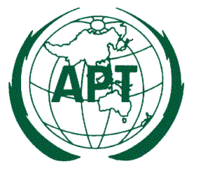
ASIA-PACIFIC TELECOMMUNITY
12/49 Soi 5, Chaeng Watthana Road, Bangkok 10210, Thailand

 |  | 7 April 2015
Subject: | Circulation of the ASTAP Questionnaire Approved at the ASTAP-25 Meeting

Dear Sir/Madam,
As you may recall, the 25th APT Standardization Forum (ASTAP-25) held in Bangkok, Thailand from 2 to 6 March 2015, was completed successfully. The meeting approved one new questionnaire, the detail of which is tabulated below:

No. | Title of the Questionnaire | Target Responder | Concerned EG and Contact detail
1. | Questionnaire on the Use-Cases for the Disaster Information and Communication System using Vehicles | APT Members, Associate Members, Affiliate Members | ASTAP Expert Group Bridging Standardization Gap  (EG BSG)  Contact:  Mrs. Nguyen Thi Khanh Thuan, Chairman EG BSG (ntkthuan@mic.gov.vn)

You are kindly requested to complete the attached questionnaire and return it to the APT Secretariat (e-mail: aptastap@apt.int) by 30 May 2015 prior to the ASTAP-26 which will be held from 09 to 12 September 2015.

I thank you in advance for your cooperation.

Yours sincerely,

Areewan Haorangsi
Secretary General

To: APT Members, Associate Members, Affiliate Members

Attachment:

- Questionnaire on the Use-Cases for the Disaster Information and Communication System using Vehicles

